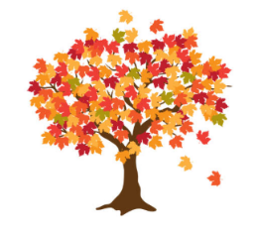Maple Class Curriculum Statement

Autumn term (first half)

Dear Parents/Carers

Welcome to Maple Class. I hope that you have all had a wonderful summer holiday.

This half term our topic is Hockwold and Beyond. We will be finding out about our local area; it’s geography and historical past. Please feel free to send in objects, books and photos that will help us with our learning. We will also be comparing our environment and school life with a school in India.

In Science we will be looking at our planet; how we use energy and what alternatives we can use to make our planet greener.

In Art and DT, we will be making creations from recycled and reclaimed materials.

In English we will be reading The Magic Porridge Pot and writing instructions to make porridge.

In Maths we will be following the White Rose scheme for a mixed age group.

**PE** – this will be on a **Monday and Thursday afternoon.**

**Please send your child into school wearing their PE kit on PE days. Please can you make sure that any long hair is tied up and no jewellery (including earrings) are worn.**

**Thank you.**

A fruit snack will be available on a daily basis.

Please remember to bring a named water bottle in each day to ensure that your child is able to keep themselves hydrated.

Please do not hesitate to contact us should you have any questions or queries.

Many thanks

Maple Class Team