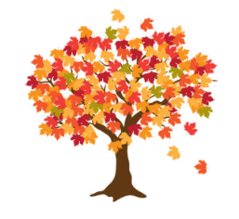
Maple Class Curriculum Statement
Autumn term (first half)
Dear Parents/Carers
We hope you all had a lovely summer holiday.
You will see that I have added some subject vocabulary that we will be using this half term. Please have a talk with your child about the vocabulary and what it means.
English – we will be following Grammasaurus. For the first couple of weeks, we will be concentrating on grammar with short burst writing opportunities. Then we will be using a text called Marvellous Minibeasts and finding out how to write a non-chronological report.
Phonics/Spellings – we will continue to use Little Wandle. Year 1s are continuing with Phases 3 and 4 and then moving onto phase 5. Year 2s will start the new Little Wandle programme called Little Wandle spelling that will review Phase 5, move onto Bridge to Spelling and then Spelling Units.
Maths - we will be following the White Rose scheme for a mixed age group class. The skills that we will be learning this half term will be place value, addition and subtraction.
Science –we will be learning about; Animals including humans.
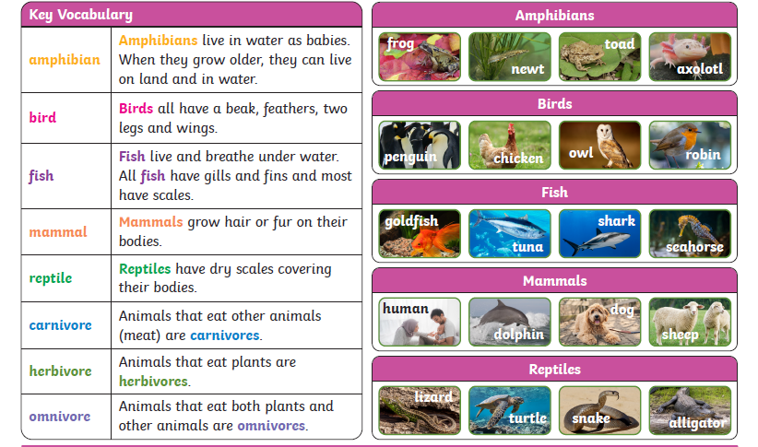
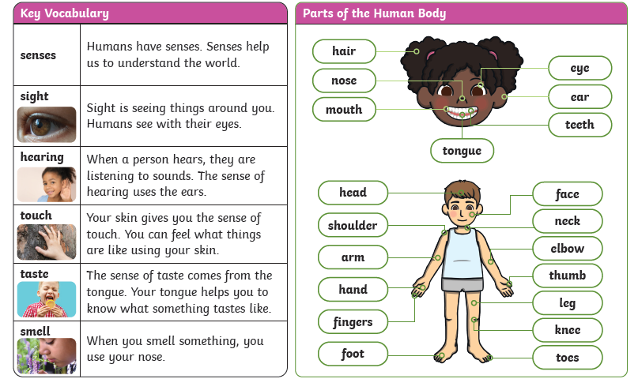
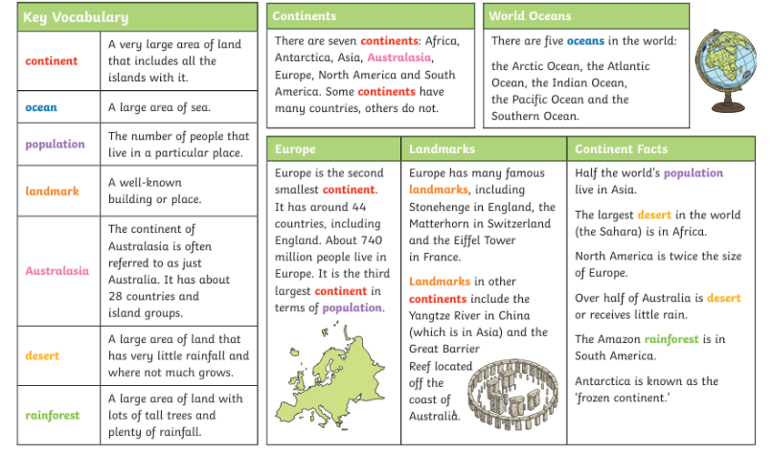
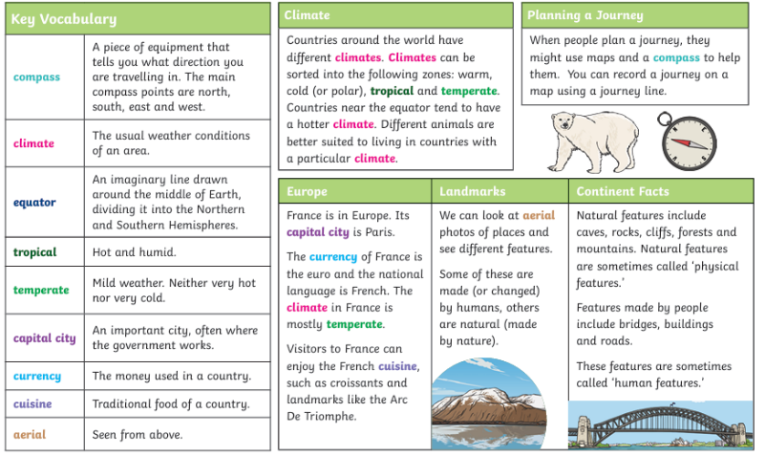
Geography our topic will be Continents and Oceans of the World.

PSHE – our focus will be Being Me in my World. We will be learning how we are safe and special, about our class, rights and responsibilities, feeling proud, consequences and what a learning charter is.
RE- What do Christians believe about God?
Computing we will be learning how to program and make a robot move.
Art – we will be looking at portraits by looking at paintings by these artists, Klee, Picasso and Andy Warhol.
Music – we are going to learn about rhythm.
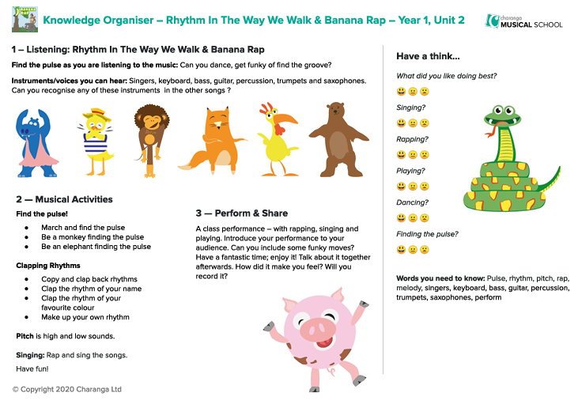
PE – our sessions will be on a Monday and Thursday. We will be looking at fitness and team building.
Please send your child into school wearing their PE kit on PE days. Please can you make sure that any long hair is tied up and no jewellery (including earrings) are worn. Thank you.

Homework
We are continuing to use Reading Eggs, Writing Legends and Mathletics. We will be rewarding the effort that the children make with Dojos.

Please remember to bring a named water bottle in each day to ensure that your child can keep themselves hydrated.

Just a reminder that snack should be a piece of fruit, pieces of vegetables like cucumber/carrot sticks or a cereal bar. Fruit is available every day.
If you’re unsure, please ask.

Please do not hesitate to contact us should you have any questions or queries.

Many thanks
Maple Class Team

