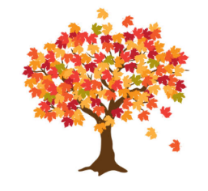
Maple Class Curriculum Statement
Autumn term (second half)
Dear Parents/Carers
I hope that you have all had a wonderful half term break.
You will see that I have added some subject vocabulary that we will be using this half term. Please have a talk with your child about the vocabulary and what it means.
English – we will be writing our own journey story and warning tale. We are following the Talk for writing approach.
Maths - we will be following the White Rose scheme for a mixed age group class.
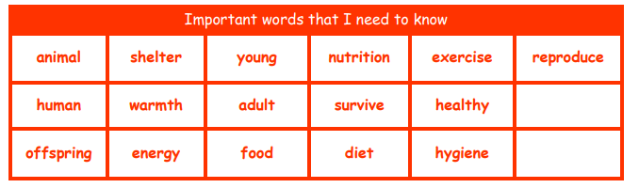
Science - we will be looking at animals including humans and their offspring.
History - we will be finding out The Victorians; what life was like, famous Victorians as well as our Marvellous Moment; a Victorian Christmas.
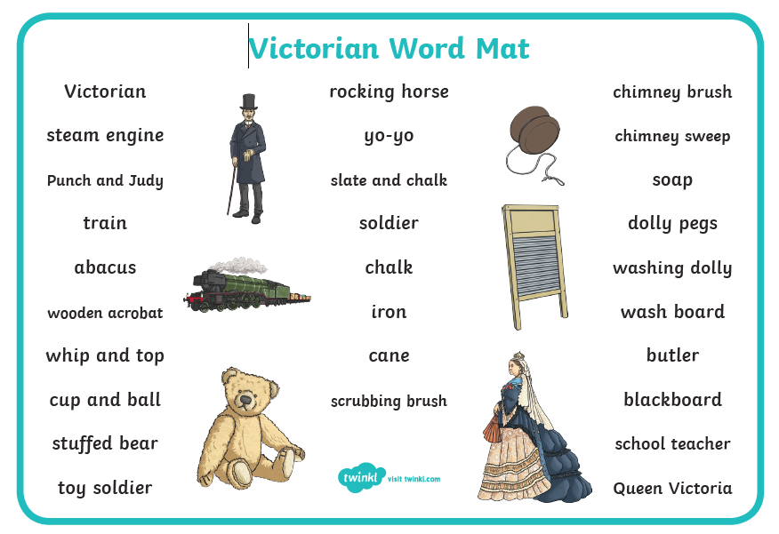

PSHE – Celebrating differences; looking at stereotypes, bullying, standing up for myself, and diversity.
Computing – we will be looking at digital photography; how we take photos and how we can improve them if they are blurry or require more lighting.
DT - we will be finding out about the importance of food hygiene and safety as well as investigating food from plants and animals.
Art - we will be recreating artwork by Renoir; investigating light and shade and colour mixing.
RE – “Why do Christians believe God gave Jesus to the world?” Linked to Christians believing that Jesus as a gift from God – Christmas.
PE – this will be on a Monday and Thursday afternoon. We will be practising and developing our Ball Skills and playing Invasion Games.
Please send your child into school wearing their PE kit on PE days. Please can you make sure that any long hair is tied up and no jewellery (including earrings) are worn. Thank you.

Please remember to bring a named water bottle in each day to ensure that your child is able to keep themselves hydrated.

Just a reminder that snack should be a piece of fruit, pieces of vegetables like cucumber/carrot sticks or a cereal bar.
The cereal bars should not be covered in chocolate or marshmallows!
Fruit is available every day.
If you’re unsure please ask.

Please do not hesitate to contact us should you have any questions or queries.

Many thanks
Maple Class Team

