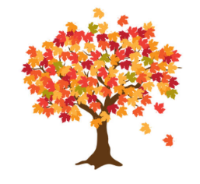
Maple Class Curriculum Statement
Spring term (first half)
Dear Parents/Carers
Wishing you all a very Happy New Year
You will see that I have added some subject vocabulary that we will be using this half term. Please have a talk with your child about the vocabulary and what it means.
English – we will be writing our own journey story. Our text will be The Papaya who spoke! We are following the Talk for Writing approach. The skills we will be learning are sentence writing, using past tense – ed words, expanded noun phrases and making sure our letters are formed correctly all the time.
Phonics/Spellings - Yr1s are continuing with Phase 5 from Little Wandle and Yr2s will be continuing with their spellings including words ending il, al, y, ies, and common exception words; find, mind, behind, old, cold, told, every, everybody.
Maths - we will be following the White Rose scheme for a mixed age group class. The skills we will be learning are related facts, addition and subtraction in 1s and 10s, multiplication and division (2s, 5s, 10s 3s), height and length and statistics.
Science - we will be looking at Materials
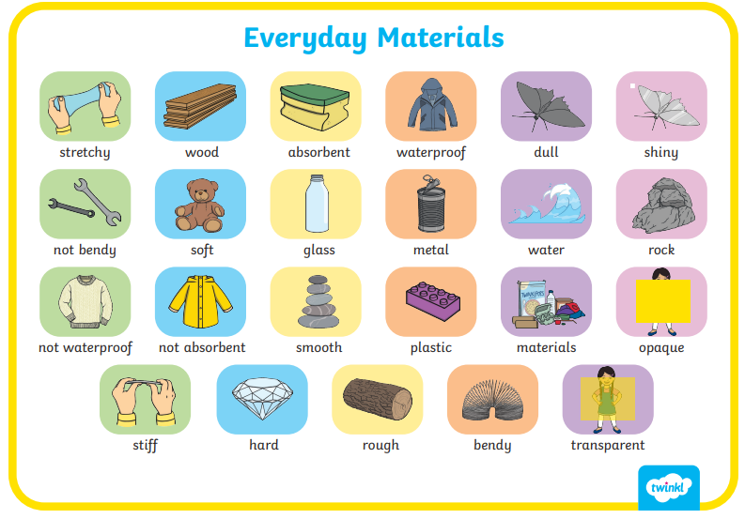

Geography - we will be finding out about the United Kingdom and its countries, Scotland, Wales, Northern Ireland and Great Britain.
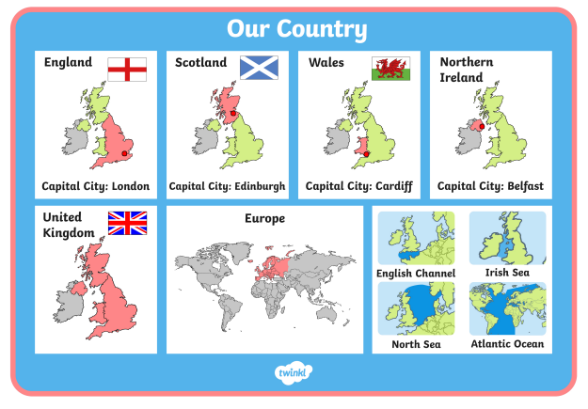
PSHE – Dreams & Goals
Computing – we will be looking at following instructions and how in computing these are called algorithms.
DT - we will be practising our sewing skills and making puppets.
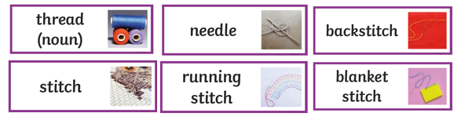
Art - we will be having a go at observational drawing; how we can use a pencil to create shade and tone.
RE – Who is God to Muslims?
PE – this will be on a Monday and Thursday afternoon. We will be practising and developing our sending and receiving skills and doing gymnastics.
Please send your child into school wearing their PE kit on PE days. Please can you make sure that any long hair is tied up and no jewellery (including earrings) are worn. Thank you.

Please remember to bring a named water bottle in each day to ensure that your child is able to keep themselves hydrated.

Just a reminder that snack should be a piece of fruit, pieces of vegetables like cucumber/carrot sticks or a cereal bar. The cereal bars should not be covered in chocolate or marshmallows! Fruit is available every day. If you’re unsure, please ask.

Please do not hesitate to contact us should you have any questions or queries.

Many thanks
Maple Class Team

