
Maple Class Curriculum Statement
Spring term (second half)
Dear Parents/Carers
We hope you had a lovely February half term.
You will see that I have added some subject vocabulary that we will be using this half term. Please have a talk with your child about the vocabulary and what it means.
English – we will be writing our own warning story. Our text will be Little Red Riding Hood. We are following the Talk for Writing approach. The skills we will be learning are sentence writing; consistently writing a perfect sentence, spelling common exception words correctly, using expanded noun phrases and inverted commas.
Phonics/Spellings - Yr1s are continuing with Phase 5 looking at alternative sounds and spilt digraphs from Little Wandle and Yr2s will be continuing with their spellings.
Maths - we will be following the White Rose scheme for a mixed age group class. The skills we will be learning are height and length and statistics.
Science – we will be learning:
- To know that the push to make their rocket fly is a force.
- To recognise that when their rocket slows down and stops there is a cause.
- To identify different light sources, including the sun.
- To know that darkness is the absence of light – investigate the best material for blackout glasses.
- The Planets – know simple facts about each planet
- Astronaut food – changes by removing and adding water

History we will be looking at how the history of space travel has changed over the years. We will be creating a timeline as well as looking at the lives of famous astronauts like Neil Armstrong, Helen Sharman and Tim Peake.
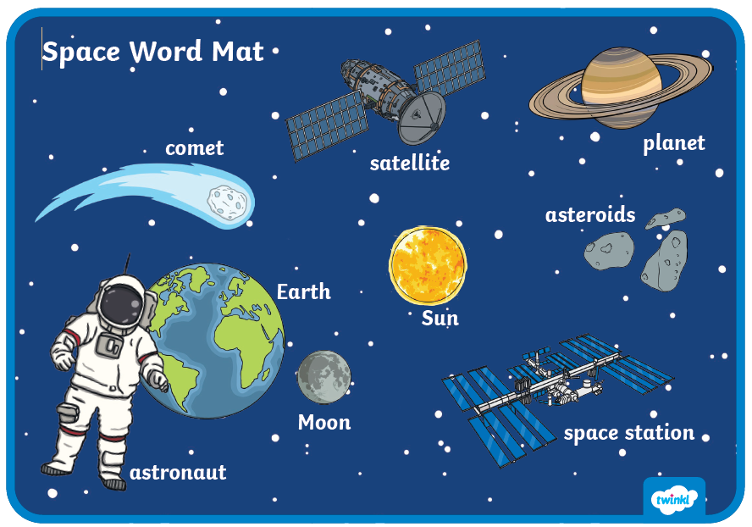
PSHE – we will be keeping ourselves healthy, looking at the importance of keeping fit, eating the right foods as well as learning how to look after our mental health.
RE- our enquiry question - Why was Jesus welcomed like a king or celebrity by the crowds on Palm Sunday? We will be looking at the Easter story and looking at people we admire.
Computing – we will be looking at constructing pictograms and how using a tally can help with counting.
DT - we will be practising our sewing skills and making puppets.
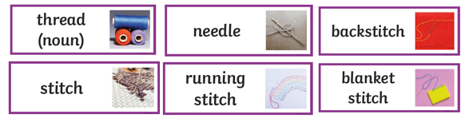
PE – this will be on a Monday we will be learning a dance routine ready to perform at the Easter Celebration. On Thursday we will be honing our skills to play target games.
Please send your child into school wearing their PE kit on PE days. Please can you make sure that any long hair is tied up and no jewellery (including earrings) are worn. Thank you.

Exciting Extras
We will be performing our Easter Dance and welcoming a visit from Wonderdome and journeying into space.

Please remember to bring a named water bottle in each day to ensure that your child is able to keep themselves hydrated.

Just a reminder that snack should be a piece of fruit, pieces of vegetables like cucumber/carrot sticks or a cereal bar. The cereal bars should not be covered in chocolate or marshmallows! Fruit is available every day. If you’re unsure, please ask.

Please do not hesitate to contact us should you have any questions or queries.

Many thanks
Maple Class Team

