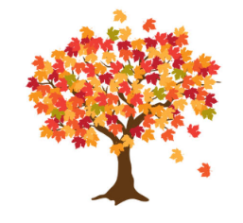
Maple Class Curriculum Statement
Summer term (first half)
Dear Parents/Carers
We hope you all had a lovely Easter hols.
You will see that I have added some subject vocabulary that we will be using this half term. Please have a talk with your child about the vocabulary and what it means.
English – We are following the Talk for Writing approach and we will be writing our own non-chronological report. Our model text will be called The Snatchling. The skills we will be learning are what makes a non-fiction report different from a story. We will be writing facts, using titles, sub-titles and writing paragraphs.
Phonics/Spellings – Yr 1s are continuing with Phase 5 looking at alternative sounds and spilt digraphs from Little Wandle and Yr 2s will be continuing with their spellings.
Maths - we will be following the White Rose scheme for a mixed age group class. The skills that we will be learning are money, fractions, time and capacity.
Science –we will be learning about;
- Growing plants from seeds
- Growing plants from bulbs
- What plants need to grow
- Do plants grow without warmth, water or sunshine?
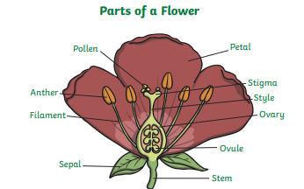
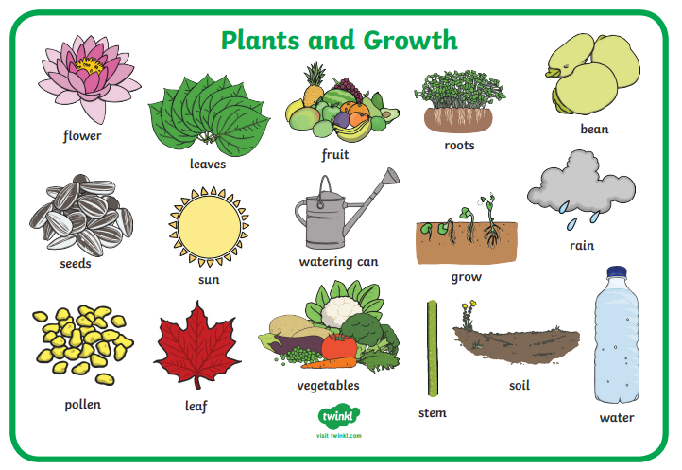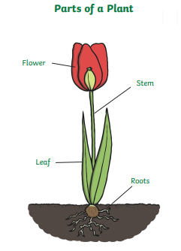

Geography We will be finding out about the 2 coldest places on Earth – The Arctic and Antarctica.
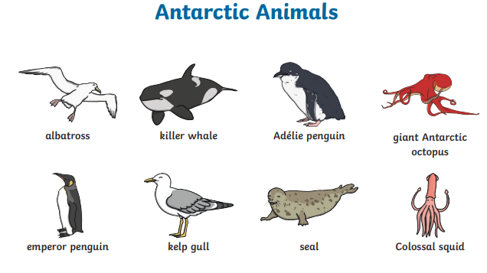
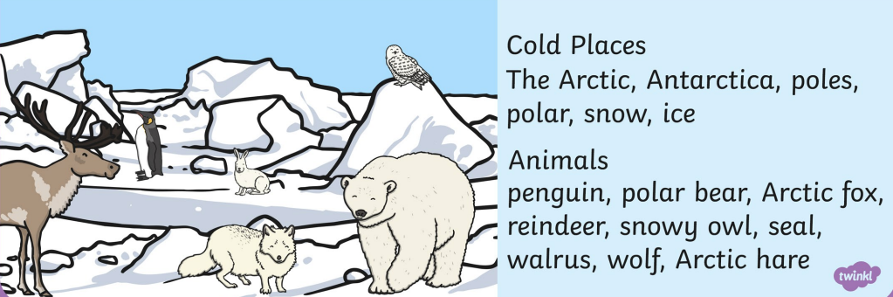

PSHE – We will be looking at Relationships with our families and friends.
RE- our enquiry question – How important is the Qu’ran to Muslims? We will be learning about Islam through stories and finding out about what Muslims believe.
Computing We will be exploring the world of digital music and having a go at becoming composers.
Art – we will be looking at the work of nature sculpturer Andy Goldsworthy and making our own sculptures using a variety of natural materials.
PE – On a Monday we will be honing our skills and tactics with striking and fielding activities. On a Thursday we will be practising net skills.
Please send your child into school wearing their PE kit on PE days. Please can you make sure that any long hair is tied up and no jewellery (including earrings) are worn. Thank you.

Exciting Extras
Growing a giant sunflower – dojo prizes for the winner!

Please remember to bring a named water bottle in each day to ensure that your child is able to keep themselves hydrated.

Just a reminder that snack should be a piece of fruit, pieces of vegetables like cucumber/carrot sticks or a cereal bar. The cereal bars should not be covered in chocolate or marshmallows! Fruit is available every day. If you’re unsure, please ask.

Please do not hesitate to contact us should you have any questions or queries.

Many thanks
Maple Class Team

