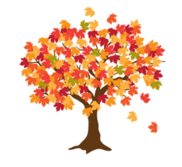
Maple Class Curriculum Statement
Summer term (second half)
Dear Parents/Carers
We hope you all had a lovely half term holiday.
You will see that I have added some subject vocabulary that we will be using this half term. Please have a talk with your child about the vocabulary and what it means.
English – We will be focussing on the composition of letter writing using the model text Me and My Dragon and Man on the Moon.
Phonics/Spellings – Yr 1s are continuing with Phase 5 looking at alternative sounds and spilt digraphs from Little Wandle and Yr 2s will be continuing with their spellings.
Maths - we will be following the White Rose scheme for a mixed age group class. The skills that we will be learning are mass, capacity and time.
Science –we will be learning about; Animals including humans.
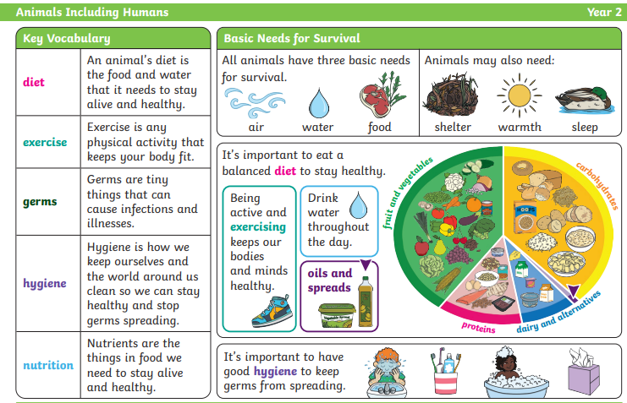
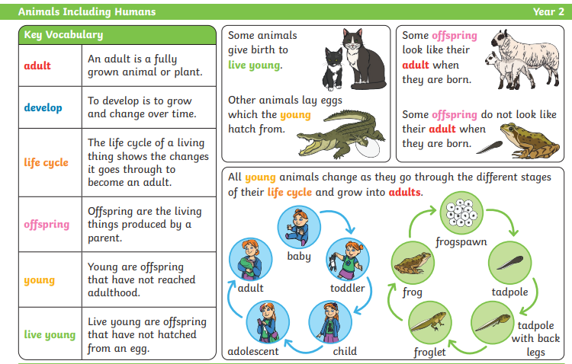
History We will be comparing past and present seaside holidays. We will be looking at historical documents showing where people went on holiday, what they wore, what they did for entertainment and comparing them with seaside holidays of today.
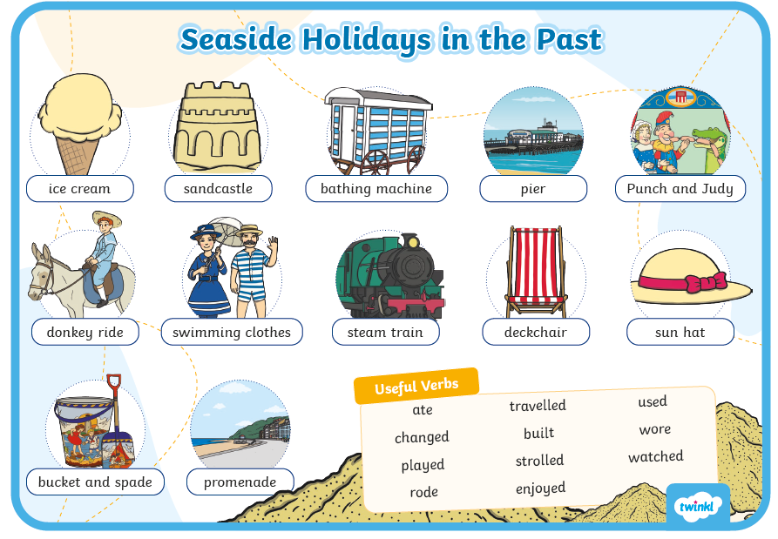
PSHE – We will be looking how we are changing as we grow older. This includes changes in our bodies, how we feel and things we are looking forward to as we move into the next year group. We will be using the correct scientific vocabulary for genitalia; testicles, penis, vulva, vagina and anus.
RE- We will be looking at how different festivals from different religions celebrate the natural world.
Computing We will be exploring how to make programme quizzes.
Art – we will be looking at how we can create overlay art maps to explore our likes, our environment and our feelings. We will be using paint, pastels and charcoal.
DT - we will be making and looking at bridges and other structures.
Music – we are going to compose and create soundscapes of the sea.
PE – On a Monday we will be developing our athletic skills. On a Thursday we will be practising our track skills in preparation for Sports Day.
Please send your child into school wearing their PE kit on PE days. Please can you make sure that any long hair is tied up and no jewellery (including earrings) are worn. Thank you.

Exciting Extras
Sports Day, Summer Fair, Diversity week, Enterprise week and our trip to the Sealife Centre.

Please remember to bring a named water bottle in each day to ensure that your child can keep themselves hydrated. As we hopefully continue to have better weather, please send your child in with a named sun hat and sun cream.

Just a reminder that snack should be a piece of fruit, pieces of vegetables like cucumber/carrot sticks or a cereal bar. The cereal bars should not be covered in chocolate or marshmallows! Fruit is available every day. If you’re unsure, please ask.

Please do not hesitate to contact us should you have any questions or queries.

Many thanks
Maple Class Team

