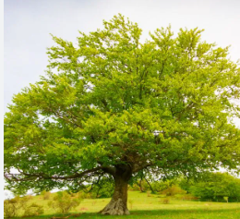

**Viking**

**Half-termly Curriculum Statement: Spring 2**

This Half Term PE will be on Mondays (dance) and Thursdays (golf with Mrs Hovell).

This half term our topic is Invaders and Settlers. We are very excited about exploring the kings of the past, the justice system and why the Vikings invaded. Our Sensational Starter will certainly get their brains working to think like a Viking by creating and comparing their own Viking shields and bracelets. Our quality text will be a non-fiction text – Looking After Cats and Dogs, followed by Elf Road by Pie Corbett.

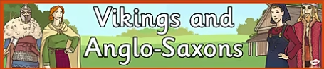

For Science, we are learning about sound; knowing that sound needs something to travel through, pitch, vibrations, high and low noise and making our own instruments.

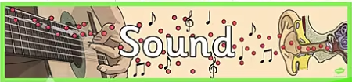

Homework will continue to be given out on a weekly basis; in addition, reading continues to be a high priority with a minimum of 5 reads per week. Children need to get their reading diary signed by an adult, or they will unfortunately not get the raffle ticket for that read. Please see the separate letter, issued before half term, to see how the BEAR project is changing.

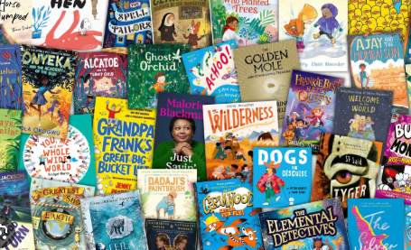

Here is our timetable for the first part of the Spring Term.

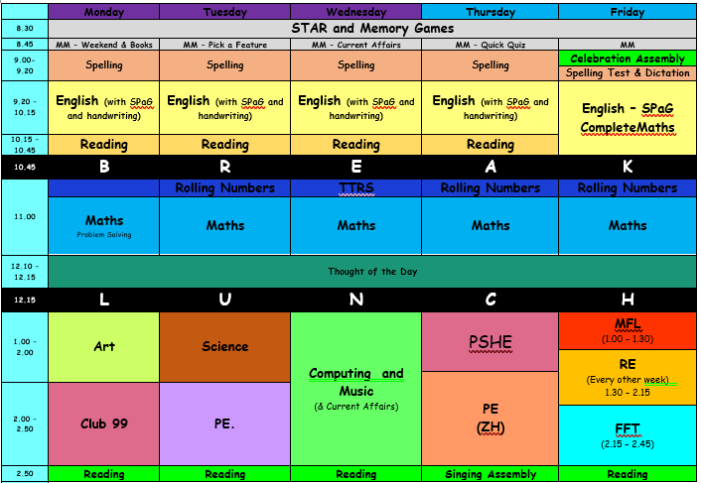

Finally, we are planning a Fantastic Finish which will involve a visit to West Stow Anglo-Saxon village.

Kind regards,

Mrs Sismey and the Beech team!

In Maths this half term, we will continue to look at multiplication and division. We will continue to practise our times tables daily and would encourage the use of TTRS at home too. If your child is not able to access this at home, please sign them up for homework club. The Year 4s will be taking their Multiplication Times table Check this year (a national test) so any practice at home to support the children is very beneficial to their success.

Homework will now be set on a Tuesday to be collected the following Monday.

Spelling tests will continue to be on a Friday. Please read with your child at least 5 times a week as, in Key Stage 2, children who have not read or completed their homework will be given an extra opportunity to complete these tasks on a Friday breaktime.

We’re really looking forward to a fantastic half term.

Kind regards,

Team Beech

You will have received a letter about the new approach to spelling.  Here are the spellings your child will be learning in school this half term. Children will have a test out of 20 which includes all spellings from that week plus a recap on previous weeks spellings and high frequency words.

|  |  |
| --- | --- |
| Week 1  w/b 24.2.25 | Grate, great, grown, groan, plane, plain, peace, piece, rain, reign. |
| Week 2  w/b 3.3.25 | Scent, sent, vain, vein, rode, road, steel, steal, waist, waste. |
| Week 3  w/b 10.3.25 | Bicycle, biplane, bisect, bilingual, biannual, reappear, redecorate, reapply, repay, rebuild. |
| Week 4  w/b 17.3.25 | League, plague, rogue, vague, fatigue, unique, antique, mosque, cheque, technique. |
| Week 5  w/b 24.3.25 | Chef, chalet, machine, brochure, crochet, ricochet, parachute, moustache, champagne, chute, |
| Week 6  w/b 31.3.25 | Address, busy, business, heart, fruit, breathe, strange, complete, extreme, forwards. |