Acorn Class Homework grid – Summer term 3a Topic: Watch me grow
Here is the homework for this half term. The compulsory tasks are indicated with a star and need to be competed each week.
Reading 3-5 times a week –  Remember to write in the reading record book. Raffle tickets awarded for each read. | Little Wandle homework sheets  Have a look at the new phonemes, tricky words and sentence reading.
The following tasks/activities are optional and children can be awarded up to 5 team points per task.

Leaf printing/ painting  Go on a leaf hunt in your garden or for a walk on your daily exercise, collect leaves and then use paint to print them onto paper. If you do not have paint use crayons and do leaf rubbings.  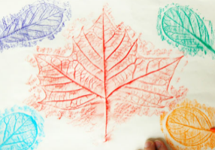   | Write some facts and make a fact file about your favourite flower, plant or a tree.  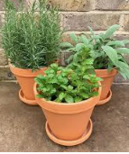  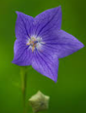  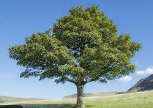 | Have a look online for some great nature ideas; make a Lego bird table, a mini pond,  a nature star, a bird feeder.  Make it activities | WWT  