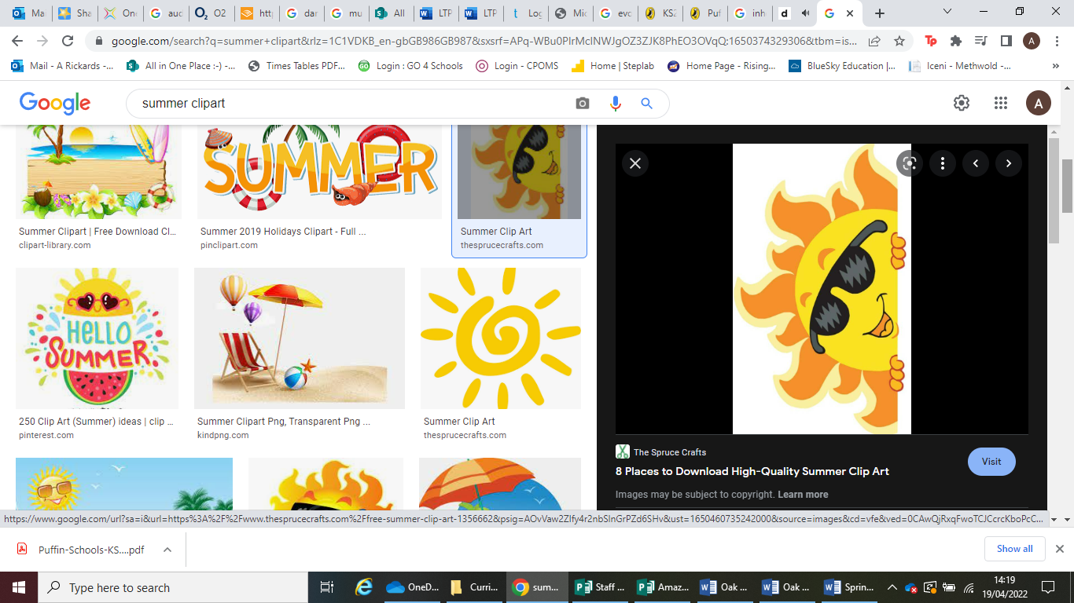

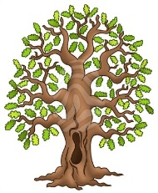**Half-termly Curriculum Statement**

Hasn’t the weather been fantastic? Welcome back, Oak Class – it’s going to be a brilliant term and we’re really looking forward to Parents Evenings today and tomorrow (22nd and 23rd April). We still have a few parents who haven’t signed up so please do get in touch.

Our topic for the whole term is Evolution. To this end, please send any **photographs** of family members like parents, siblings, grandparents, aunts, uncles and cousins for a fun activity about which characteristics have been inherited (such as eye colour or tongue rolling) and which are non-inherited (like a scar from an accident). Please Dojo any photos in the chat function or we can photocopy them here if you prefer.

In Science, we will be looking at natural selection, learning about Charles Darwin and his theory of evolution.

Here is our timetable for the first part of the Summer Term.

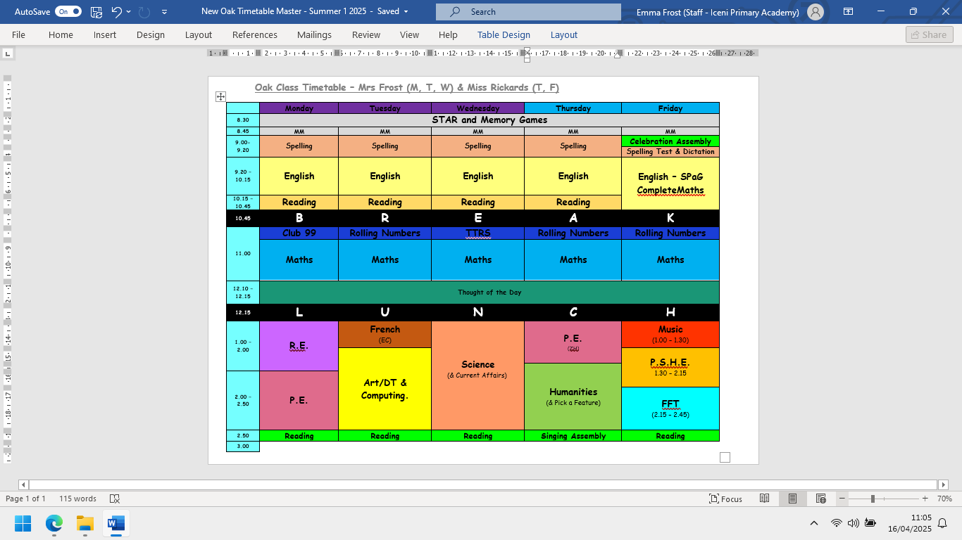

**PE continues to be on Mondays (Cricket) and Thursdays (Rounders). Please continue to send in your children wearing PE kit on those days.**

SATS week for Year 6 children being Monday 12th May. We don’t want the children to be worrying about anything! To this end we try to make the SATS week as much fun as possible. We run the annual SATS Breakfasts from 8am on 12th, 13th, 14th and 15th May – we have Croissant Monday, Pancake Tuesday, Waffle Wednesday and Leftover Thursday (as well as providing juice and alternative foods too). In addition to this, we would love to meet the Year 6s and their families at High Lodge in celebration of SATs finishing - we will send a separate letter out with all the information you will need for SATs week.

On top of that, it’s all go for Year 6 this half term: we are taking them to Crucial Crew at King’s Lynn Fire Station on Wednesday 30th April. This is a multi-agency safety education event that involves the staging of theatrical safety sets for students to learn about safety by experiencing risk in a safe, fun and controlled environment.

Our spellings for this half term are:

|  |  |  |
| --- | --- | --- |
| Words containing the letter string ‘ough’  (4 day week)    though  although  dough  trough  cough  enough  rough  tough  because | Words containing the letter string ‘ough’    borough  thorough  ought  thought  brought  bought  drought  wrought  fought  bough  plough  always | Adverbials of time  (4 day week)    yesterday  immediately  previously  recently  earlier  finally  tomorrow  later  lately |
| Words with an /ear/ sound spelt ‘ere’    sincere  hemisphere  austere  atmosphere  interfere  persevere  severe  sphere  adhere  mere  here  cashmere | Statutory Spelling Challenge Words    amateur  ancient  bargain  muscle  queue  recognise  twelfth  identity  develop  harass  embarrass  foreign |  |

We’re really looking forward to another fantastic term in Oak Class.

Kind regards,

**Team Oak – Mrs Frost, Miss Rickards and Mrs Stubbings**

