Acorn Class Homework grid - Summer term (second half) Topic: Water, water everywhere!
Here is the homework for this half term. The compulsory tasks are indicated with a star and need to be competed each week.
Reading 3-5 times a week –  Remember to write in the reading record book.  Raffle tickets awarded for each read. | Little Wandle homework sheets  Have a look at the new phonemes, tricky words and sentence reading.
The following tasks/activities are optional and children can be awarded up to 5 team points per task
Weekend news – write a sentence for each weekend of the half term. What have you enjoyed doing? Where did you go? Who did you go with?  Remember a perfect sentence has a capital letter at the beginning, a full stop at the end, finger spaces and it must make sense. | 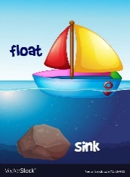  Carry out your own floating and sinking experiment. Collect a range of different objects, can you predict whether you think they will float or sink? Test your guesses were you right? | Make an under the sea picture. You could use paint, felt tips, crayons or have a go at making a shoe box into a fish tank!  