

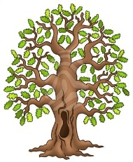**Half-termly Curriculum Statement**

Welcome back, Oak Class – we’re going to have a fantastic time this half term. There’s the residential in it for a start!

Our topic for this half term continues to be about Evolution with the scientific side of things focusing on humans developing to old age and the impact of diet and exercise on lifestyle.

Important dates specifically for Oak Class this half term are as follows:

* Year 6 begin part two of their swimming on Monday 9th June – we will send a separate letter.
* Also on Monday 9th June is a two-part meetingat 3pm beginning with an opportunity to share with parents only the content and format of the Relationships and Sex Eduation sessions for this half term; it is always really empowering for teachers and parents to know what will be covered in these sessions so please attend if you can – Mrs Sismey has kindly offered to entertain your children in Beech classroom for the duration of this part of the meeting.
* The second part of the meeting is about the residential to Hilltop on 25th-27th June. The children can join us for this as they’ll find out what activities they’ll be doing, the menu we’ve been given and about the kit list.
* PE continues to be on Mondays and Thursdays.
* Tuesday 1st July is set for our Summer Show – this is an opportunity for your child to perform on stage if they would like to. We’ve had magic shows, roller skaters, dancers, gymnasts, singers, comedians – anything goes (as long as it’s safe!). 😊We’ll Dojo more information about it soon – in the meantime, the children can get their thinking caps on!

Here is our timetable for the second part of the Summer Term.

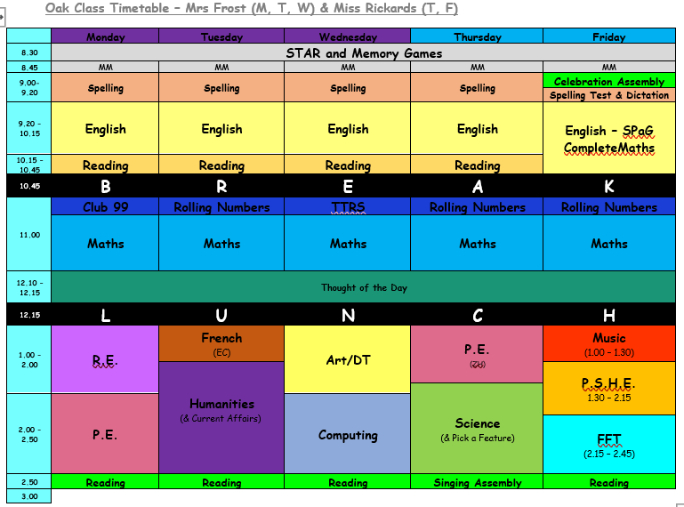

**PE continues to be on Mondays (Cricket) and Thursdays (Rounders). Please continue to send in your children wearing school PE kit on those days.**

Our spellings for this half term are:

|  |  |  |
| --- | --- | --- |
| **Unstressed vowels in polysyllabic words**    definite  desperate  literate  secretary  stationary  dictionary  Wednesday  familiar  original  animal | **Adding verb prefixes de- and re-**  deflate  deform  decode  decompose  defuse  recycle  rebuild  rewrite  replace  revisit | **Adding verb prefix over-**  overthrow  overturn  overslept  overcook  overreact  overestimate  overuse  overpaid  overlook  overbalance |
| **Convert nouns or verbs into adjectives using suffix -ful**    boastful  faithful  doubtful  fearful  thankful  beautiful  pitiful  plentiful  fanciful  merciful | **Convert nouns or verbs into adjectives using suffix -ive**    attractive  creative  addictive  assertive  adhesive  co-operative  exhaustive  appreciative  offensive  expressive | **Convert nouns or verbs into adjectives using suffix -al**  musical  political  accidental  mathematical  functional  tropical  professional  central  global  industrial |

(Additional spellings will be added each week that have been identified in class.)

We’re really looking forward to another fantastic term in Oak Class. Kind regards, **Team Oak – Mrs Frost, Miss Rickards and Mrs Stubbings**

