

**Oak Class**

**Autumn 1 – Curriculum Statement**

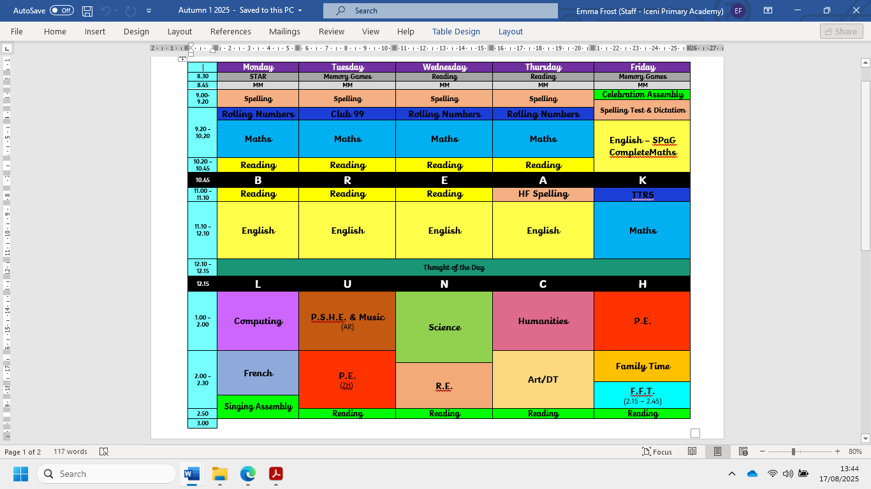

Welcome back to the new school year in Oak Class! The weather is still hot and I for one am very much looking forward to the cooler weather now! We have an action-packed term ahead of us including…

**Science** – Forces all around us! We will be looking at the forces that surround us from gravity to water resistance to friction and air resistance.

**Humanities** – In Geography, we will be studying all about Africa, locating countries, key geographical features and the climate changes across the continent. For the history aspect, we will be studying the Atlantic Slave trade. We will be focussed on the human impact, what it meant for each point of the slave trade triangle and finding all about the Underground Railroad and the abolition of the slave trade.

**Art and DT** – Will have an African focus, using African artist Edward Said Tingatinga and sculpture as inspiration for our work.

**Music –** World music and African drumming.

**PE** will be on Tuesdays and Fridays.

**The Reading Raffle** continues with tickets available every week. If your child forgets to bring their reading record home for you to sign or you have been unable to sign it, please message me via Dojo on a Friday to let me know they have read.

**Spellings –** Please see below the list of spellings for this half term. We will also be spending time with most children on some of the high frequency words that need a little work 😊.

|  |  |  |  |  |  |  |  |  |  |  |  |
| --- | --- | --- | --- | --- | --- | --- | --- | --- | --- | --- | --- |
| |  |  | | --- | --- | | **Ambitious synonyms:** | | | aggressive hostile  awkward obstinate desperate frantic  disastrous calamitous marvellous spectacular | | |  |  | | --- | --- | | **Homophones & near homophones: Nouns that end in -ce/-cy and verbs that end in -se/-sy** | | | advice  advise  device  devise  licence  license  practice  practise prophecy prophesy | | |  |  | | --- | --- | | **Adjectives ending in -ant into nouns ending in -ance/-ancy** | | | observant observance expectant expectancy hesitant  hesitancy  tolerant tolerance  relevant relevance | |
| |  |  | | --- | --- | | **Adjectives ending in -ent into nouns ending in -ence/-ency** | | | innocent  innocence  decent  decency  excellent  excellence confident confidence existent existence | | |  |  | | --- | --- | | **Hyphens: To join a prefix ending in a vowel to a root word beginning with a vowel** | | | co-operate  co-ordinate  co-own  co-author  re-enter  re-educate  re-examine  re-evaluate  re-energise  re-elect | | |  |  | | --- | --- | | **Hyphens: To join compound adjectives to avoid ambiguity** | | | man-eating little-used rock-bottom wide-eyed pig-headed tight-fisted cold-hearted stone-faced green-eyed short-tempered | |

* Additional weeks will be revision and consolidation.

As always, if you have any questions or anything you would like to chat about, please just get in touch 😊.

Kind regards,

Mrs Frost, Mrs Stubbings and Mrs Noble