

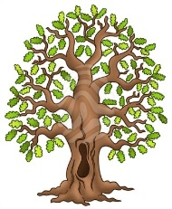 **Curriculum Statement**

**Year 3 & 4 Curriculum Statement – Autumn Term**

Welcome back! We are excited to begin a new school year full of discovery, creativity and learning together. After a well-deserved summer holiday, the children will be settling back into routines and diving into a wide range of engaging topics.

**English**  
Our class text this term is Leo and the Place Between. Through this story, we will be developing reading comprehension, vocabulary and descriptive writing, as well as exploring themes of imagination, adventure and storytelling.

**Mathematics**  
We begin the term by focusing on place value. The children will strengthen their understanding of number, ordering, comparing and rounding, as well as recognising the importance of digits and the value of each place within a number.

**History**  
Our history topic is the Shang Dynasty of Ancient China. Children will explore what life was like during this fascinating period, looking at beliefs, achievements and the legacy of the Shang people.

**Religious Education**  
This term we will be learning about the Sikh faith. Children will develop an understanding of Sikh beliefs, values and traditions, and explore the importance of community and equality in Sikhism.

**Music**  
Music lessons will continue with Miss Rickards, where the children will enjoy singing, listening and performing, as well as learning about rhythm and musical expression. This half term, children will be learning about Chinese Pentatonic music.

**PE**  
PE will take place on Mondays and Thursdays. Please ensure children have their correct PE kit in school on these days.

We are looking forward to a positive, exciting and productive term ahead!

**Reading**

Reading is at the heart of all learning - it helps children build vocabulary, imagination, and understanding of the world around them. Just a few minutes of reading together each day makes a big difference to their confidence and progress. Please continue to hear your child read at least 5 times a week and please do remember to sign their reading record book. Reading Raffle; on a Friday we will add up how many times you have heard your child read and give them the same number of raffle tickets which will then be drawn randomly, and they could win a bag of sweets!

Here is our timetable for the Autumn Term.

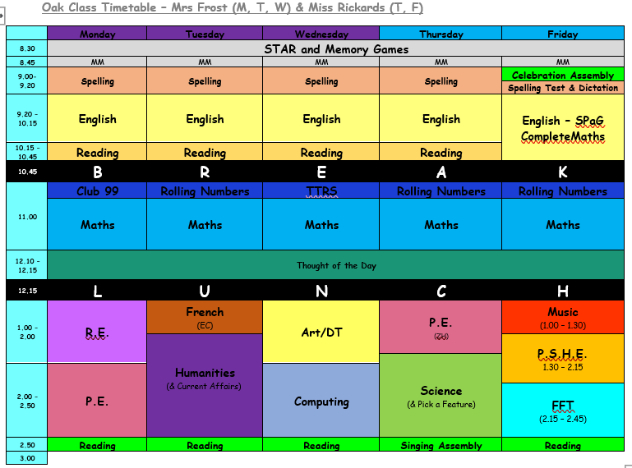

**PE will be on Mondays (Cross country ) and Thursdays (Team building). Please continue to send in your children wearing school PE kit on those days.**

Our spellings for this half term are:

|  |  |  |
| --- | --- | --- |
| **Words with /aw/ spelt with augh and au**  Caught  naughty  taught  daughter  autumn  clause  cause  astronaut  applaud  author | **Adding the prefix in- (meaning ‘not’ or ‘into’)**  inactive  incorrect  inaccurate  insecure  indefinite  incomplete  infinite  inedible  inability  indecisive | **Adding the prefix im- (before a root word staring with ‘m’ or ‘p’)-**  immature  immeasurable  impossible  immortal  imperfect  impatient  immovable  impolite  important  improper |
| **Adding the prefix il- (before a root word staring with ‘l’) and the prefix ir- (before a root word staring with ‘r’)**  illegal  illegible  illogical  illiterate  illicit  irregular  irrelevant  irresponsible  irrational  irresistible | **Homophones & near homophones**  medal  meddle  missed  mist  scene  seen  board  bored  which  witch | **Words with /shun/ endings spelt with ‘sion’ (if root word ends in ‘se’, ‘de’ or ‘d’)**  division  invasion  confusion  decision  collision  television  revision  erosion  inclusion  explosion |

(Additional spellings will be added each week that have been identified in class.)

We’re really looking forward to another fantastic term in Beech Class. Kind regards, **Team Beech – Mrs Sismey, Mrs Noble and Mrs** **Evans.**