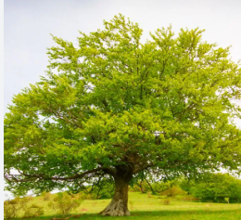

Half-termly Curriculum Statement: Autumn 2

We hope you had a restful and enjoyable half term. As we return to school, Beech Class has a busy and exciting term ahead filled with creative learning, new experiences, and opportunities to explore the world around us.
This term, we’ll continue our exploration of China, with a particular focus on Shanghai, as part of our Geography learning. We’ll be comparing life in Shanghai to life in the UK, looking at its landmarks, climate, and culture, and using maps and data to deepen our understanding of this fascinating global city.
In English, our core text will be The Cobbler of Krakow and Smok the Dragon. We’ll be using this rich and imaginative story to develop our reading comprehension, vocabulary, and creative writing skills, including character descriptions, dialogue, and story structure.
In Maths, we’ll be focusing on multiplication and division, building fluency with times tables, understanding arrays, and solving word problems using practical strategies.
In Science, our topic is Reduce, Reuse, Recycle. We’ll explore how materials are used, how waste affects the environment, and what we can do to make sustainable choices. Pupils will investigate materials and their properties, and take part in hands-on activities to promote eco-friendly thinking.


In Computing, we’ll be learning how to create our own stop-frame animations, combining storytelling with digital skills. Pupils will plan, shoot and edit short animated sequences using classroom devices.
Our RE focus is on Sikhism, where we’ll explore the question: Do Sikhs think it is important to share? Through stories, discussion, and reflection, children will learn about Sikh beliefs and practices, with a focus on kindness and community.
In PSHE, we’ll be celebrating what makes us unique in our unit on Celebrating Difference. Pupils will explore identity, respect, and how to build positive relationships.
PE will take place on Mondays and Thursdays, with a focus on netball and football. Children will develop teamwork, coordination, and tactical skills through fun and active sessions.
In DT, we’ll be inspired by Chinese cuisine and will learn how to prepare and cook our own spring rolls, exploring ingredients, taste, and food safety.
In Music, pupils will be learning to play the steel pans, developing their listening, rhythm, and ensemble skills through hands-on practice and performance.
In French, we’ll be recapping previous learning and building vocabulary around colours, shapes, and size, using games and songs to reinforce understanding.
We’re also looking forward to our upcoming pantomime trip, which promises to be a fun and festive highlight of the term! More details to follow.
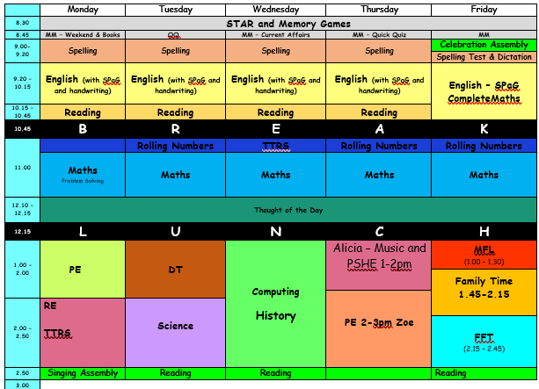
Finally, a reminder that children should be reading at least five times a week. For every five reads (and more!), they’ll earn a raffle ticket for the chance to win a sweet treat in our weekly draw.

Our spellings for this half term are:
 | Words with a /shuhn/ sound, spelt with ‘ssion’ (if root word ends in ‘ss’ or ‘mit’)  expression  discussion  confession  permission  admission  transmission  possession  profession  depression  impression | Words with a / shuhn/ sound, spelt with ‘tion’ (if root word ends in ‘te’ or ‘t' / or has no definite root)  Invention  injection  action  question  mention  attraction  translation  devotion  position  solution
  Words with a /shuhn/ sound, spelt with ‘sion’ (if root word ends in ‘se’, ‘de’ or ‘d’)
  Expansion
  extension comprehension
  tension
  corrosion supervision
  fusion
  conclusion persuasion suspension
Words with a /shuhn/ sound, spelt with ‘cian’ (if root word ends in ‘c’ or ‘cs’)  musician  politician  electrician  magician  mathematician  dietician  statistician  technician  clinician  beautician | Words with ‘ough’ to make a long /o/, /oo/ or /or/ soundmedal  though  although  dough  through  breakthrough  thought  bought  brought  fought  ought | Statutory Spelling Challenge Words  interest  experiment  potatoes  favourite  imagine  material  promise  opposite  minute  increase

Kind regards,
Mrs Sismey and the Beech team!

Here are some key words you might like to look at with your child.

