Dear Parents and Carers,
We hope you’ve all had a wonderful half term!
I’m very excited for this half term ahead, as it includes my favourite season — Christmas! 🎄
This term promises to be full of excitement and discovery as we learn about different celebrations from around the world. We have lots of fun activities planned, including pumpkin pie baking, a Stay and Play session inspired by Handa’s Surprise, and of course, our Christmas performance! ✨
Below, you’ll find an overview of what we’ll be learning and exploring this term, please do go through some of the vocabulary listed.
As always, if you have any questions, please don’t hesitate to come and speak to us — we’re always happy to help. You can also visit our class page on the school website for updates and information.
Mrs. Barrow and the Acorn Team
Personal, Social and Emotional Development

This term we will continue to learn how to take turns, play nicely together and share.

We will also look at kindness, being calm, considering feelings of others and keeping ourselves safe through our topic lessons.

Maths
We will continue to learn about numbers 1, 2, 3, 4 & 5. Where we will also look at 1 more and 1 less than a number and subitising.
We will also learn to identify, name and sort circles, triangles and 4 sided shapes.

Phonics
We will continue our Phase 2 phonics this half term, learning new sounds — including some digraphs (two letters that make one sound). Children will begin to write and spell simple CVC words (e.g. cat, dog, sun) and read short sentences containing the phonemes we’ve learned so far.
Phonemes and words learned each week will continue to be sent home at the end of the week via class Dojo.

English
We will be reading the story Take a Walk Little Bear.
Learning to re-tell the story verbally and with actions and creating our own story using pictures and written words we can spell based on our phonic knowledge.
We will also look at and learn about instructions when we write our own class instructions on how to look after a pet.

Acorn Class
Curriculum Statement
Autumn 2
Celebrations!
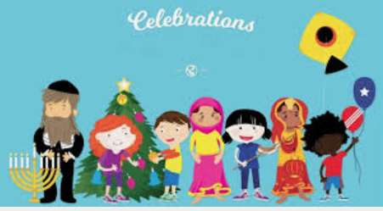

Communication and Language
To further our communication and language we will;
- Engage in story time and have weekly communication and language sessions.
- Re-tell the story Take a Walk Little Bear.
- Promote speaking in full sentences
- Encourage listening carefully to each other.
- Give instructions on how to look after a pet.

Understanding of the World.
We will be learning about all the different celebrations from around the world. We will do this through, dance, art, geography and design technology.
We will also be baking pumpkin pies and performing our Christmas play. Details of this will be sent closer to the time.

Vocabulary: Guy Fawks, safety, remembrance, poppy, Winter, Spring, Summer, Autumn, Africa, kindness, thankful, Buddhists, Buddha, calm, Jewish, Menorah, Chirstian, Jesus, Mary and Joseph, Bethlehem, Christmas.

Expressive Art and Design

We will be exploring and using different media and materials to create:
- Firework pictures and poppy printing.
- Collages
- Threading to create bracelets/ necklaces.
- Clay Menorah’s.
Vocabulary:
Paint, flicking, collage, rip, tear, cut, printing, cutting, threading, build, mould, shape.

Physical Development
To develop our physical development, we will continue to take part in activities such as; funky fingers, dough disco, pencil control and handwriting activities.
PE will be taught by Mrs. Hovell on Tuesday afternoons.
Please make sure children come to school in their PE kit with long hair tied back and earrings removed.

We have also incorporated all areas of learning into the Continuous Provision within Acorn Class.

