

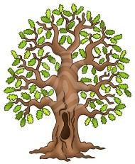
Curriculum Statement
Welcome back! We hope you have all had a wonderful Christmas holiday and enjoyed a well-earned break. As we begin the new term, the children will be settling back into routines and diving into an exciting range of learning opportunities.

English
Our main text this term is the suspense story Staying Out. Through this narrative, the children will develop their reading comprehension, explore rich vocabulary, and learn how writers build tension and atmosphere. They will also be creating their own suspense writing using techniques such as show-not-tell, powerful verbs and descriptive detail.

Mathematics
In maths, we will be focusing on multiplication and division. The children will deepen their understanding of number relationships, practise efficient methods, and apply their skills to problem-solving and reasoning tasks. Times tables fluency will continue to be a key priority.

Science
Our science topic this term is Animals Including Humans. Children will learn about the digestive system, the functions of different teeth, and how tooth decay occurs. They will also investigate how to keep teeth healthy through practical enquiry and scientific observation.

History
This term, our topic is the Stone Age. Children will explore what life was like during this prehistoric period, including homes, tools, food, art and early human survival. They will compare different eras within the Stone Age and consider how life has changed over time.

PE
PE will take place on Mondays and Thursdays. Please ensure children have the correct PE kit in school on these days.

Reading
Reading is at the heart of all learning. It helps children build vocabulary, imagination and a deeper understanding of the world. Just a few minutes of reading together each day makes a huge difference to their confidence and progress. Please continue to hear your child read at least five times a week and remember to sign their reading record.
Reading Raffle: Each Friday, we will count how many times your child has read at home. They will receive the same number of raffle tickets, and one lucky winner will receive a small prize!
We are looking forward to a positive, exciting and productive term ahead with the children.

Here is our timetable for the Spring Term.
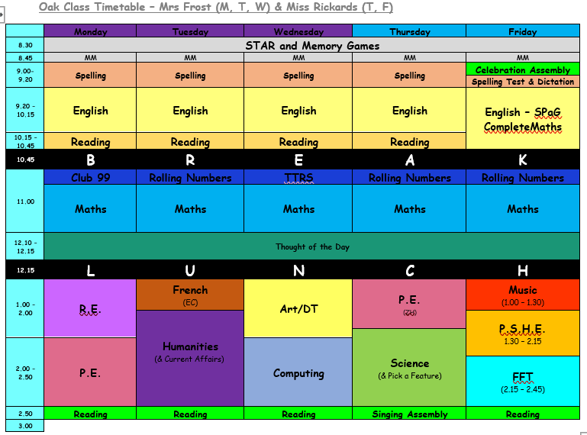
PE will be on Mondays (Yoga ) and Thursdays (gymnastics). Please continue to send in your children wearing school PE kit on those days.
Our spellings for this half term are:
Homophones & near homophones  accept  except  affect  effect  aloud  allowed  weather  whether  whose  who’s | Homophones & near homophones  cereal  serial  check  cheque  through  threw  draft  draught  stares  stairs | Nouns ending in the suffix -ation  information  adoration  sensation  preparation  education  location  exaggeration  concentration  imagination  organisation
Nouns ending in the suffix -ation  creation  radiation  indication  ventilation  relegation  dedication  demonstration  abbreviation  translation  vibration | Adding the prefix sub- (meaning ‘under’) and adding the prefix super- (meaning ‘above’)  submerge  subheading  submarine  subordinate  subway  superman  supervise  supersede  superpower  superhuman | Plural Possessive Apostrophes with plural words  girls’  boys’  babies’  parents’  teachers’  women’s  men’s  children’s  people’s  mice’s
(Additional spellings will be added each week that have been identified in class.)
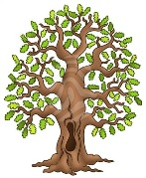
We’re really looking forward to another fantastic term in Beech Class. Kind regards, Team Beech – Mrs Sismey, Mrs Noble and Mrs Tollman.

