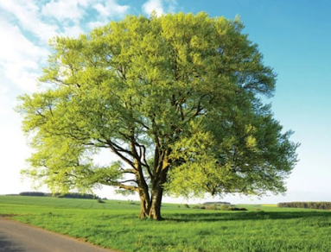

Welcome back! We hope you all had a wonderful half-term and enjoyed a well-earned break. In this half term, the children will be settling back into routines and diving into an exciting range of learning opportunities across the curriculum.

English
This term, our English work will focus on non-fiction writing. The children will explore how writers use persuasive language and will work towards creating a letter encouraging a bully to change their behaviour. They will learn to use emotive language, rhetorical questions, clear reasons and positive suggestions to strengthen their writing.

Mathematics
In maths, we will be developing our understanding of fractions. The children will explore unit and non-unit fractions, equivalent fractions and fractions of amounts. They will use practical resources, visual models, and reasoning tasks to deepen their confidence and fluency.

Science
Our science topic this term is Rocks. The children will investigate different types of rocks, compare their properties and explore how fossils are formed. They will also learn about soil and carry out simple tests to classify rocks based on hardness, permeability and durability.

Geography
In geography, our topic is Somewhere to Settle. The children will learn about the features that make a good settlement, including land use, water sources, shelter and safety. They will compare different types of settlements and consider why early humans chose certain places to live.

DT
In Design and Technology, the children will be designing and making their own Stone Age roundhouse. They will explore structure, materials and historical design before creating a model roundhouse using a range of construction techniques.

Exciting Extras This Term
We have lots of special experiences planned, including:
- Wonderdome – an immersive space-themed learning experience
- Dance with Miss Emily, leading to a performance later in the term
- First Aid training for Year 4 - Friday 27th February
- World Book Day, where we will celebrate reading with a range of fun activities

Reading
Reading remains at the heart of our curriculum. Just a few minutes of reading at home each day makes a huge difference to children’s confidence and progress. Please continue to hear your child read at least five times a week and sign their reading record.
Reading Raffle: Each Friday, we count how many times your child has read at home. They receive the same number of raffle tickets, and one lucky winner receives a small prize.
We are looking forward to a positive, exciting, and productive term ahead with the children.

Here is our timetable for the Spring Term.
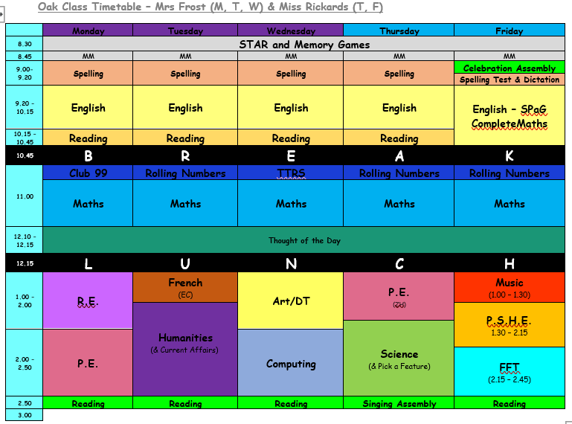
PE will be on Mondays (Dance with Miss Emily ) and Thursdays (Dance with Mrs Hovell). Please continue to send in your children wearing school PE kit on those days.
Our spellings for this half term are:
Words with the /s/ sound spelt with ‘sc’  science  crescent  discipline  fascinate  scent  scissors  ascent  descent  scientist  scenery | Words with a ‘soft c’ spelt with ‘ce’  centre  century  certain  recent  experience  sentence  notice  celebrate  ceremony  certificate | Words with a ‘soft c’ spelt with ‘ci’  circle  decide  medicine  exercise  special  cinema  decimal  accident  city  citizen
Word families based on common words, showing how words are related in form and meaning  phone  phonics  microphone  telephone  homophone  real  reality  realistic  unreal  realisation | Word families based on common words, showing how words are related in form and meaning  solve  solution  insoluble  dissolve  solvent  sign  signature  assign  design  signal | Statutory Spellings Challenge Words  length  strength  purpose  history  different  difficult  separate  suppose  therefore  knowledge
(Additional spellings will be added each week that have been identified in class.)
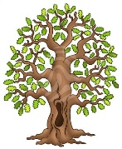
We’re really looking forward to another fantastic term in Beech Class. Kind regards, Team Beech – Mrs Sismey, Mrs Noble and Mrs Tollman.

