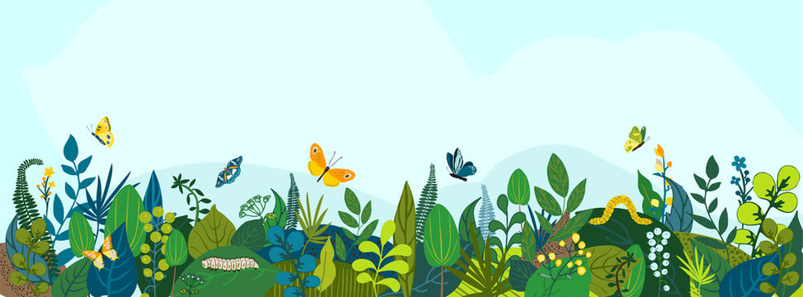
Oak Class
Spring 2 – Curriculum Statement
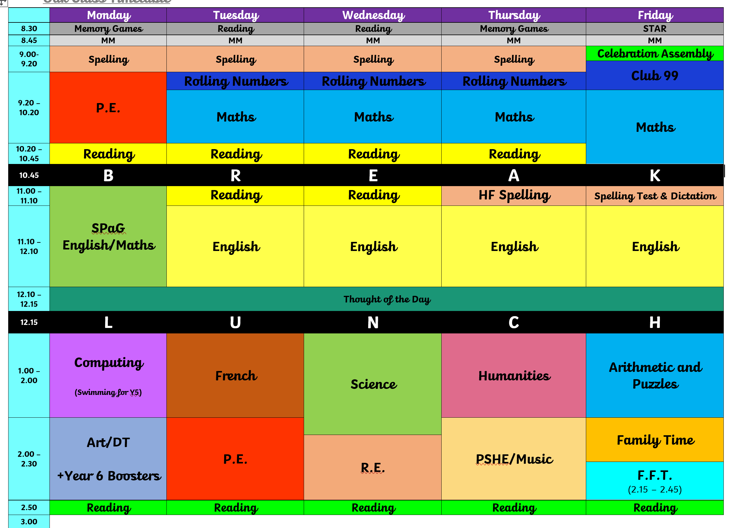
Welcome back! Wow, this year is speeding by! I hope you are all enjoying the lighter mornings and evenings! In the next five weeks, we have lots of exciting things taking place!

Science – How does light travel?
Humanities – We will be continuing with our topic on the Fen’s and looking more at the history of the fens and the Fen Tigers. This will be supported by our trip to Wicken Fen.
Computing – we will be studying vector graphics using PowerPoint to make 2D images (Year 5’s swimming).
R.E. – We will be looking again into the Hindu faith and asking, ‘How can Brahman be everywhere and in everything?’
Design & Technology and Art – We will be finishing off our junk model vehicles (we’re still waiting for the wheels to arrive) and then moving on to our art topic – Nature and the artist Andy Goldsworthy (Year 5’s swimming).
P.S.H.E. - Being and keeping safe and healthy.
PE will be on Mondays and Tuesdays.

The Reading Raffle continues with tickets available every week. If your child forgets to bring their reading record home for you to sign or you have been unable to sign it, please message me via Dojo on a Friday to let me know they have read.
We will be reading Skandar and the Unicorn Thief.

Spellings – Please see below the list of spellings for this half term. We will also be continuing with our work on the high frequency words with most children .
  Words with endings which sound like /shuhl/ after a vowel letter
  official
  Special
  artificial
  social
  racial
  crucial
  facial
  beneficial
  superficial
  antisocial
  foreign
  apparent
  Words with endings which sound like /shuhl/ after a consonant letter
  partial
  confidential
  essential
  substantial
  torrential
  sequential
  potential
  spatial
  martial
  influential
  appreciate
  persuade
  Words with a ‘soft c’ spelt /ce/
  cemetery
  certificate
  celebrate
  necessary
  deceased
  December
  sacrifice
  hindrance
  nuisance
  prejudice
  individual
  language
  Word families based on common words, showing how words are related in form and meaning
  accommodate
  accompany
  access
  accuse
  accost
  accrue
  accuracy
  accomplish
  accumulate
  accentuate
  sufficient
  determined
  Word families based on common words, showing how words are related in form and meaning
  signature
  assign
  design
  designate
  significant
  resignation
  resign
  insignificant
  assignment
  signal
  explanation
  pronunciation
* Additional weeks will be revision and consolidation.

Useful Vocabulary:
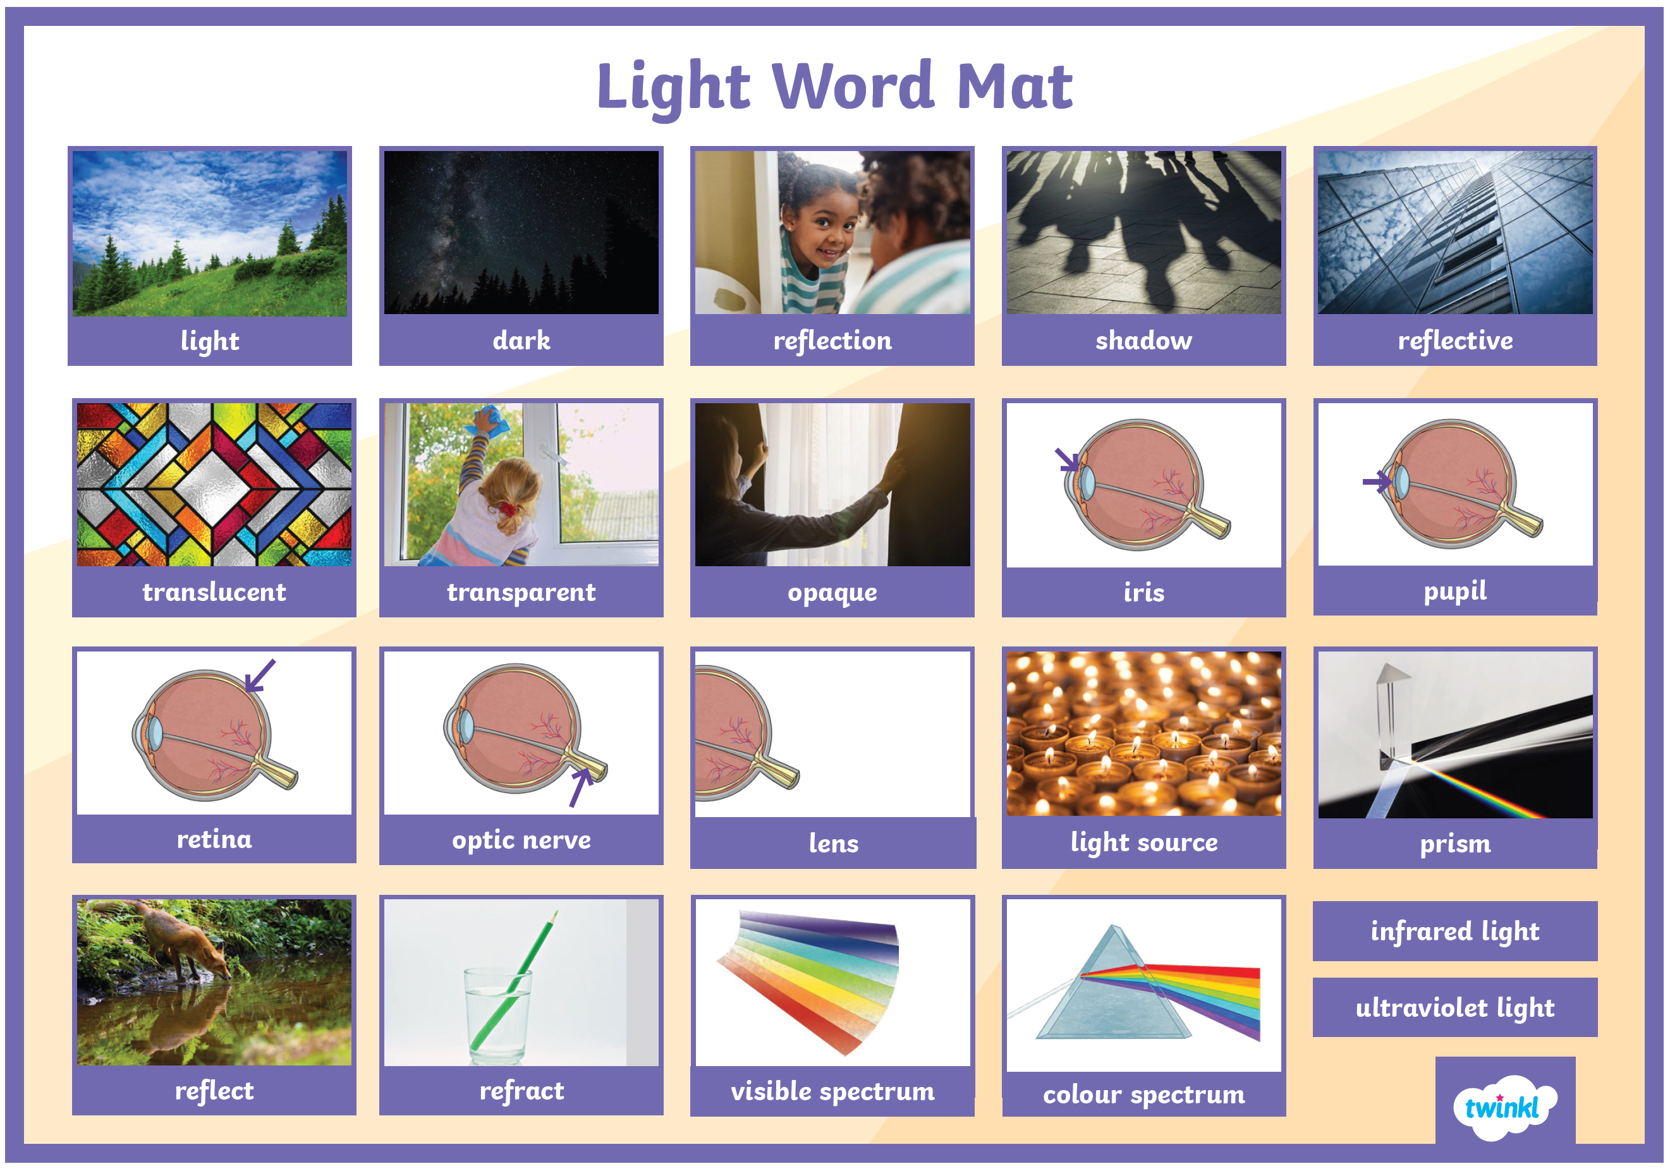
Exciting Extras:
- Weekly dance sessions with Emily, our specialist dance teacher that visits each year.
- 27.02.26 - First aid and CPR training from the East Anglian Air Ambulance.
- 05.03.26 - Oak’s Wicken Fen Trip
- 06.03.26 - World Book Day (information to follow)
- 11.03.26 - Crucial Crew (Year 6)
- 12.03.26 - The Wonderdome – experiencing space
If you have any questions or anything you would like to chat about, please just get in touch .
Kind regards,

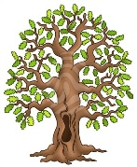
Mrs Frost, Mrs Stubbings and Mrs Evans

