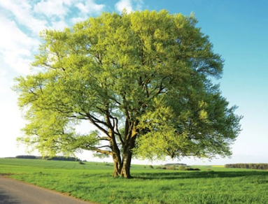

Curriculum Statement

Welcome Back!
We hope you all had a wonderful half-term and enjoyed a well-earned break. This half term, the children will be settling back into routines and diving into an exciting range of learning opportunities across the curriculum.

English
This term, our English work will focus on fiction writing. The children will explore the story of King Midas, looking closely at character, motivation and consequences. They will develop their descriptive writing, dialogue skills and story structure as they work towards creating their own version of the tale.

Mathematics
In maths, we will continue developing our understanding of fractions, building confidence with equivalent fractions, comparing and ordering fractions, and finding fractions of amounts. Later in the term, we will move on to exploring time and money, using practical activities and reasoning tasks to deepen understanding.

Science
Our science topic this half term is Living Things and Their Habitats. The children will learn how living things are grouped, explore different habitats, and investigate how animals and plants are adapted to their environments. They will also look at simple classification keys and carry out observational activities.

Geography & History
This term, our humanities focus is the Ancient Egyptians. The children will learn about:
- the importance of the River Nile
- daily life and beliefs
- pharaohs and pyramids
- mummification and ancient artefacts
They will explore how geography shaped Egyptian civilisation and compare it with modern life.

Art
In art, the children will be studying Egyptian statues and masks. They will explore traditional designs, patterns and symbolism before creating their own artwork inspired by ancient Egyptian styles.

PE
Our PE focus this half term is tennis and rounders. The children will develop their coordination, control, racket skills and teamwork through a range of fun activities and games.

Design & Technology
The children will continue to develop their creative and practical skills through a range of hands-on tasks linked to our wider curriculum learning.

Exciting Extras This Term
We have lots of special experiences planned, including:
- 🎵 Ukulele workshops with a visiting music specialist
- 🕍 Trip to Norwich Synagogue
- Rock Steady Launch session

Reading
Reading remains at the heart of our curriculum. Just a few minutes of reading at home each day makes a huge difference to children’s confidence and progress. Please continue to hear your child read at least five times a week and sign their reading record.
Reading Raffle: Each Friday, we count how many times your child has read at home. They receive the same number of raffle tickets, and one lucky winner receives a small prize.
We are looking forward to a positive, exciting and productive term ahead with the children.

Here is our timetable for the Spring Term.
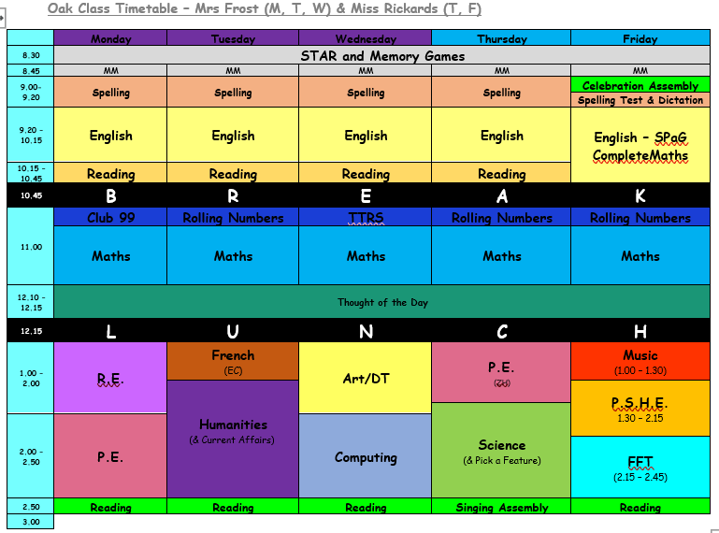
PE will be on Mondays and Thursdays. Please continue to send in your children wearing school PE kit on those days.
Our spellings for this half term are:
Adding the prefix inter- (meaning ‘between’ or ‘among’)  interact  interfere  intercity  international  intermediate  internet  intergalactic  interrupt  intervene  interlude | Adding the prefix anti- (meaning ‘against’)  antiseptic  anticlockwise  antisocial  antidote  antibiotic  antivenom  anti-ageing  antifreeze  antiperspirant  antigravity | Adding the prefix auto- (meaning ‘self’ or ‘own’)  autograph  autobiography  automatic  auto-focus  autocorrect  autopilot  autopsy  automobile  autonomy
Adding the prefix ex- (meaning ‘out’ )  exit  extend  explode  excursion  exchange  export  exclaim  expel  external  exterior | Adding the prefix non- (meaning ‘not’ )  non-stick  non-stop  non-starter  non-smoker  nonsense  non-fiction  non-drip  non-violent  non-profit  non-believer | Words ending in -ar/ -er  calendar  grammar  regular  particular  peculiar  popular  consider  remember  quarter  integer
(Additional spellings will be added each week that have been identified in class.)
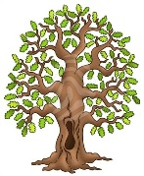
We’re really looking forward to another fantastic term in Beech Class. Kind regards, Team Beech – Mrs Sismey, Mrs Noble and Mrs Tollman.

