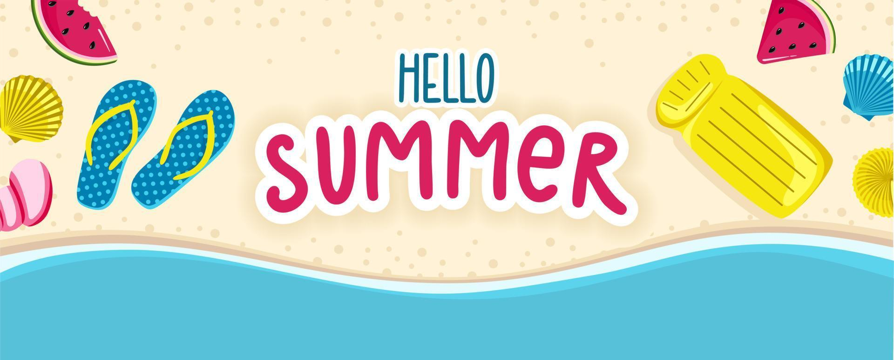
Oak Class
Summer 1 – Curriculum Statement
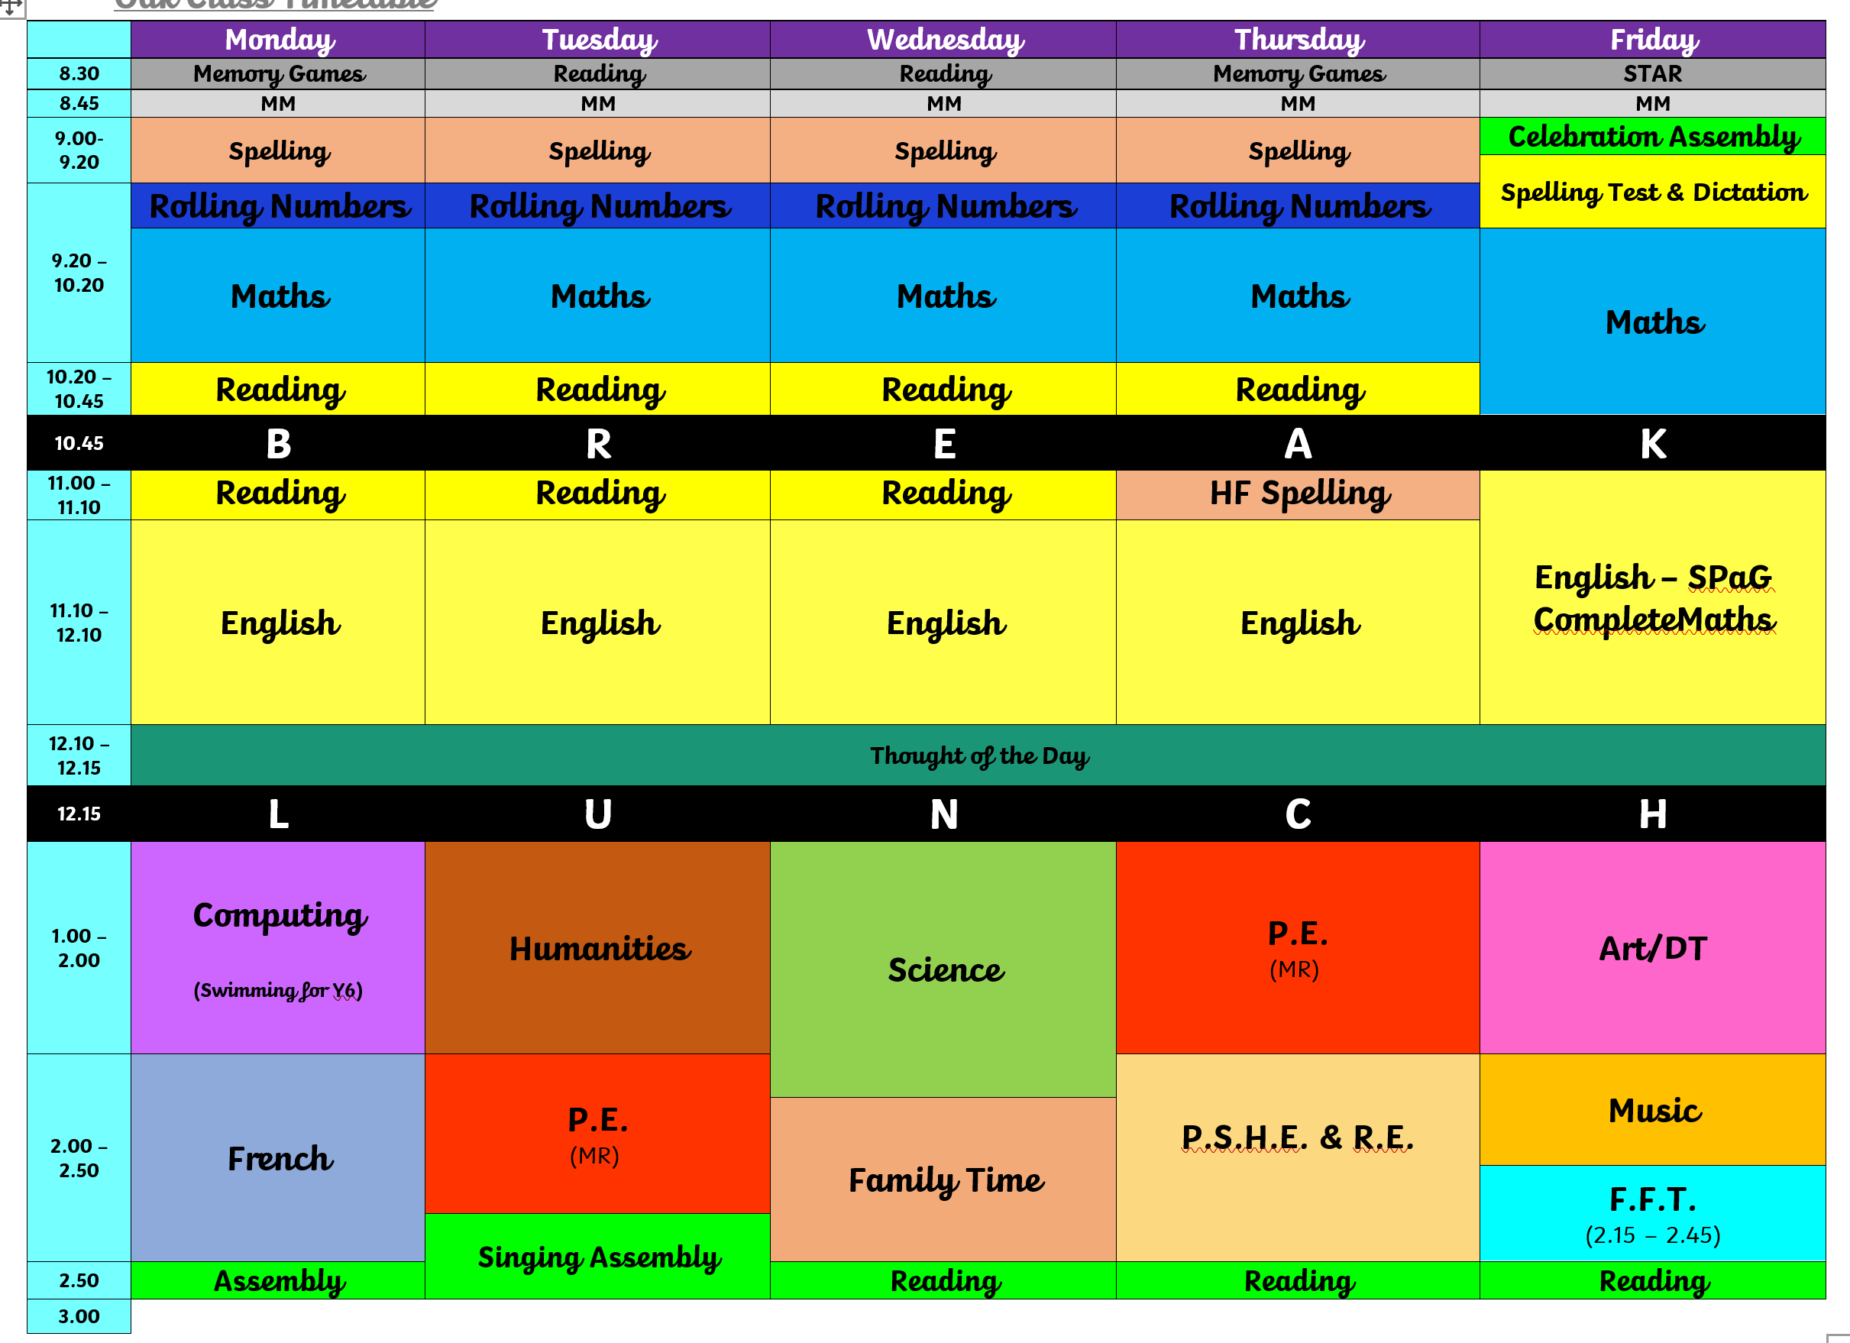
The Summer term is starting already, this year is whizzing past! So many exciting things coming up in the Summer Term and it’s an important term too – especially for our Year 6’s! Aside from SATs prep and SATs – here is what else we will be doing!

Science – Climate Change and Sustainability.
Humanities – We will be starting our new topic on the Mayan Civilisation as well as delving into the geography of the area and studying volcanoes!
Computing – Web Creation (Year 6’s swimming).
R.E. – Do beliefs in Karma, Samsara and Moksha help Santanis lead good lives?
Art – For art we will be inspired by the work from our topic on Ancient Maya and Mexican artists.
P.S.H.E. - Building positive, healthy relationships.
PE will be on Tuesdays and Thursdays with Swimming for the Year 6’s on Mondays
The Reading Raffle continues with tickets available every week. If your child forgets to bring their reading record home for you to sign or you have been unable to sign it, please message me via Dojo on a Friday to let me know they have read.
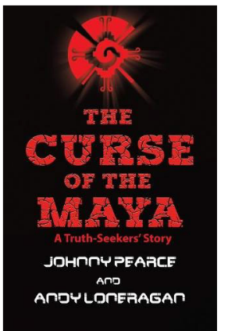
We will be reading:

Spellings – Please see below the list of spellings for this half term. We will also be continuing with our work on the high frequency words with most children .
  Word families based on common words, showing how words are related in form and meaning
  programme
  telegram
  hologram
  diagram
  grammar
  grammatical
  parallelogram
  monogram
  programmer
  program
  Words that can be nouns and verbs
  challenge
  protest
  broadcast
  benefit
  charge
  function
  influence
  interest
  object
  damage
  Words that can be nouns and verbs
  produce
  present
  reason
  silence
  support
  transport
  surprise
  scratch
  freeze
  balance
  Words with a long /o/ sound spelt ‘ou’ or ‘ow’
  shoulder
  smoulder
  mould
  poultry
  soul
  shallow
  window
  blown
  known
  thrown
  Words ending in -ible
  possible
  horrible
  terrible
  visible
  incredible
  sensible
  forcible
  legible
  responsible
  reversible
  Words ending in -ibly
  possibly
  horribly
  terribly
  visibly
  incredibly
  sensibly
  forcibly
  legibly
  responsibly
  reversibly
* Additional weeks will be revision and consolidation.
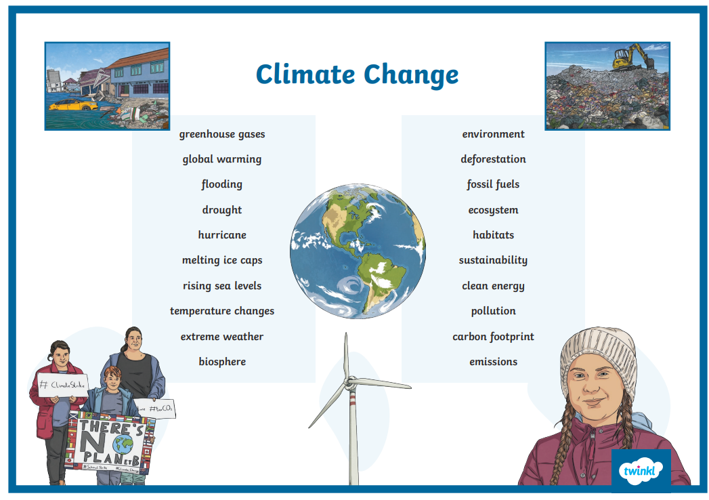
Useful Vocabulary:

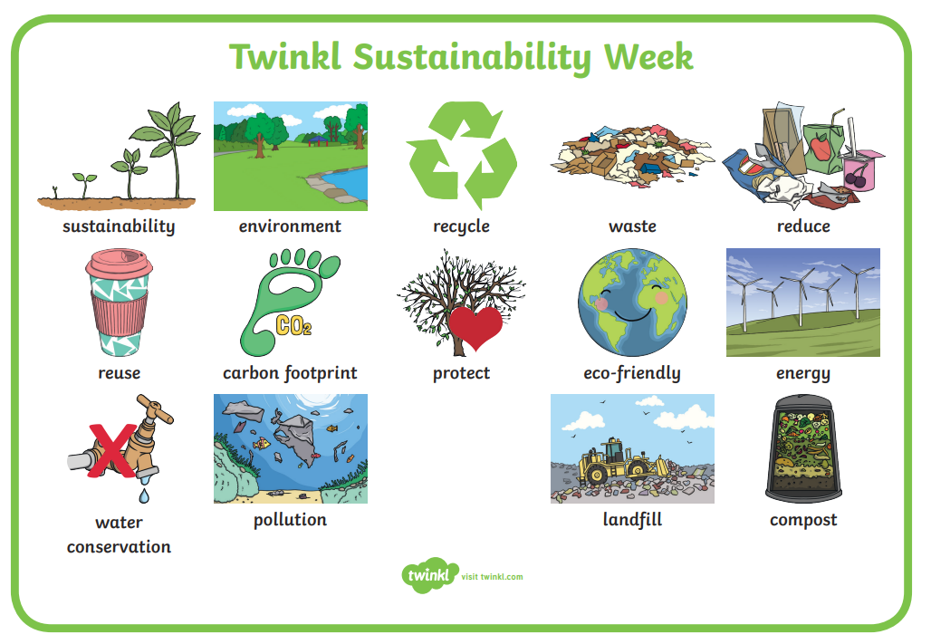

Exciting Extras:
- Most exciting of all – SATs week (11th – 14th May)
- Year 6 Swimming
- 11.05.26 – Joe Wickes LIVE
If you have any questions or anything you would like to chat about, please just get in touch .
Kind regards,

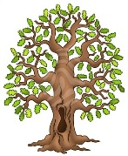
Mrs Frost and Mrs Stubbings

