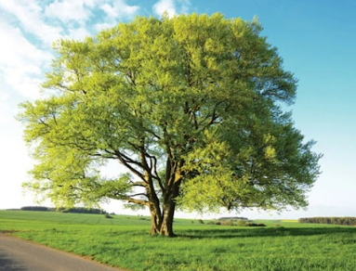

Curriculum Statement
Welcome Back!
We hope you all had a wonderful half term and enjoyed a well-earned break. As we enter the final term of our current year groups, the children will be settling back into routines and diving into an exciting range of learning opportunities across the curriculum. We will also begin our transition periods, helping to prepare the children for the next stage in their learning journey.

English
This term in English, we are exploring an adventure story called Adventure at Sandy Cove. The children will focus on developing their descriptive writing, building suspense, and structuring their own exciting stories. They will explore characters, settings, and key events, working towards creating their own seaside adventure.

Mathematics
In Maths, we will be focusing on money, as well as shape and statistics. The children will develop their understanding through practical activities, problem-solving tasks, and real-life contexts.

Science
In Science, we are learning about states of matter. The children will explore solids, liquids, and gases, and investigate how materials can change and be grouped based on their properties.

Geography & History
We will continue our study of Ancient Egypt, deepening our understanding of this fascinating civilisation. The children will explore:
- the importance of the River Nile
- how it supported life and farming
- connections to the water cycle
- key aspects of Ancient Egyptian life and achievements

PE
Our PE focus this half term is athletics, where the children will develop their running, jumping, and throwing skills, as well as teamwork and coordination.

Design & Technology
The children will continue to develop their creative and practical skills through a range of hands-on activities linked to our wider curriculum.

Exciting Extras This Term
We have lots of special experiences planned, including:
- Ukulele workshops with a visiting music specialist
- Rock Steady for those that have signed up (there is still time)
- Sports Day
- Talent Show
- Summer fete
- Diversity Week
- Enterprise
What a busy half term!

Reading
Reading remains at the heart of our curriculum. Just a few minutes of reading at home each day makes a huge difference to children’s confidence and progress. Please continue to hear your child read at least five times a week and sign their reading record.
Reading Raffle: Each Friday, we count how many times your child has read at home. They receive the same number of raffle tickets, and one lucky winner receives a small prize.

We are looking forward to a positive, exciting and productive term ahead with the children.

Here is our timetable for the Summer Term.
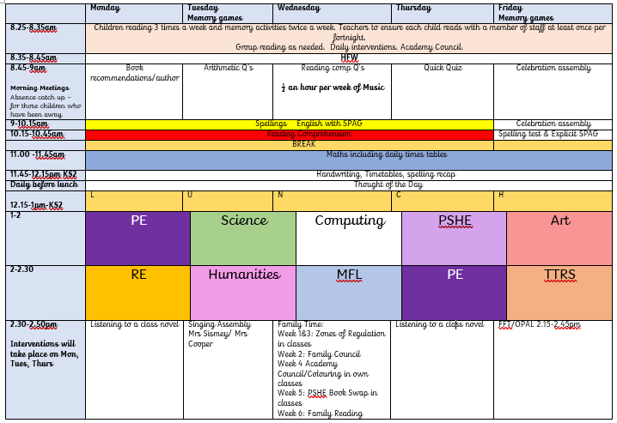
PE will be on Mondays and Thursdays. Please continue to send in your children wearing school PE kit on those days.
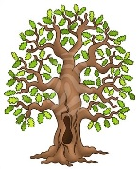
We’re really looking forward to another fantastic term in Beech Class. Kind regards, Team Beech – Mrs Sismey, Mrs Noble and Mrs Tollman.

Week 1: Acrobat, acronym, acropolis, accurate, acupuncture. acute, acuity, aeronaut, aerospace, aerobics, aerofoil | Week 2: anniversary, annual, annually, aqueduct, aquarium, aquatics, astronaut, astronomer, astrophysics, astrologer. | Week 3: bicycle, biped, binoculars, bias, bicentennial, biennial, biweekly, bilingual, biology, biography, biosphere, biodiversity
Week 4: certificate, certain, ascertain, certitude, chronography, chronic, chronological, chronicle, circle, circuit, circadian, circa. | Week 5: co-author, co-exist, co-operate, collocate, copilot, coincidental, cohesive, co-worker, corpse, corporation, corporal. | Week 6: demography, demonstrate, epidemic, democracy, demagogue, dentist, trident, dentures, diagonal, diameter, diagram.
Here’s our spellings for this half term.

