
Oak Class
Summer 2 – Curriculum Statement
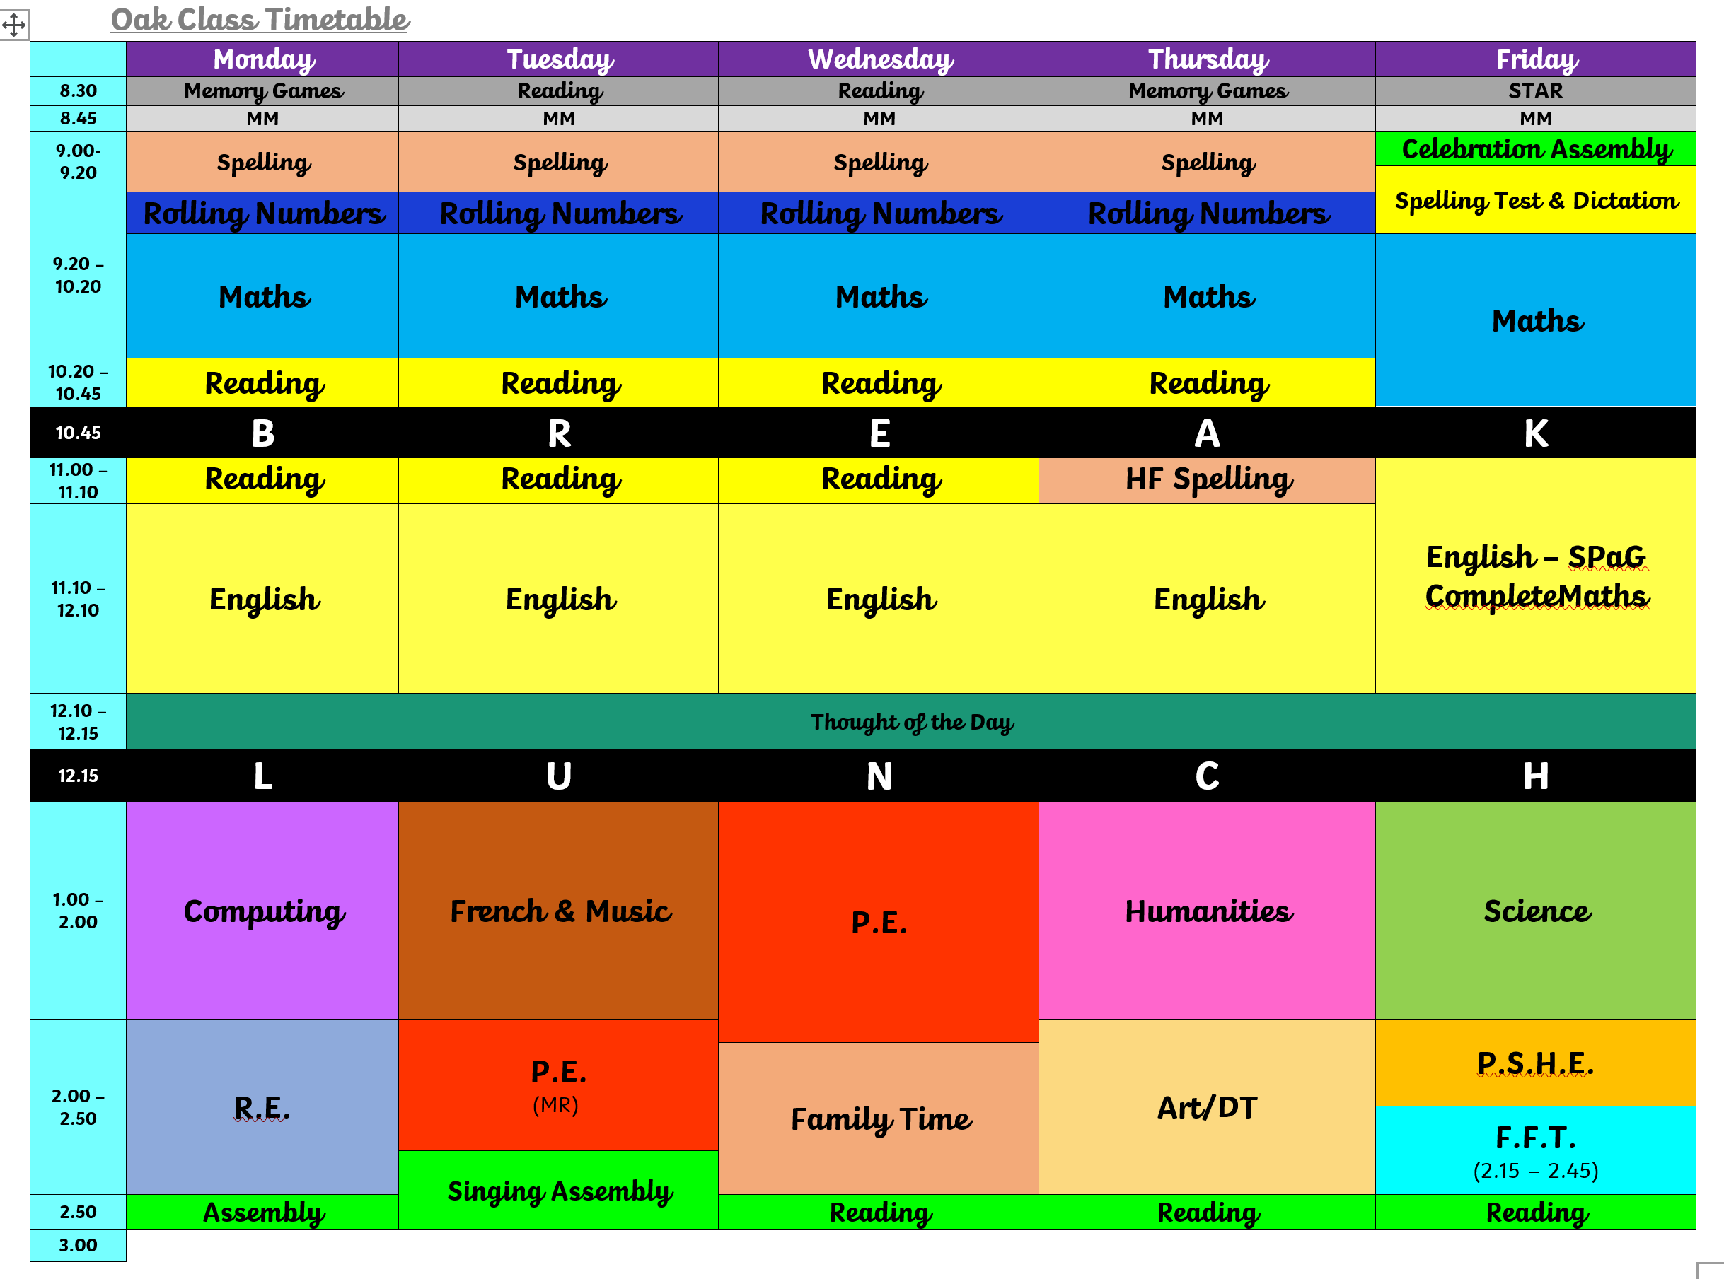
Wow! Summer 2 already – the year really has flown by! Such a busy term with lots of exciting activities and, for our Year 6’s, new adventures exploring their new schools! Here’s hoping the weather stays nice for us (but not too hot ).

Science – Earth, Sun and Moon
Humanities – We will be continuing with our topic on the Maya Civilisation as well as studying volcanoes!
Computing – 3D modelling – designing a Maya inspired temple!
R.E. – What is the best way for a Christian to show commitment to God?
Art and DT – For art we will be inspired by the work from our topic on Ancient Maya and Mexican artists.
P.S.H.E. – Changing me.
PE will be on Tuesday and Wednesday.
The Reading Raffle continues with tickets available every week. If your child forgets to bring their reading record home for you to sign or you have been unable to sign it, please message me via Dojo on a Friday to let me know they have read.
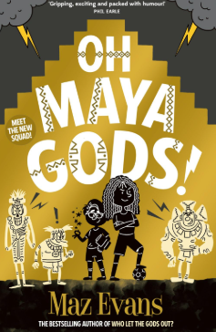
We will be reading:

Spellings – Please see below the list of spellings for this half term. We will also be continuing with our work on the high frequency words with most children .
  Words ending in -ibly
  possibly
  horribly
  terribly
  visibly
  incredibly
  sensibly
  forcibly
  legibly
  responsibly
  reversibly
  Words containing the letter string ough
  1. thorough
  2. enough
  3. though
  4. although
  5. thought
  6. through
  7. rough
  8. cough
  9. sought
  10. bought
  11. plough
  12. tough
  Words ending in -ate.
  1. appreciate
  2. communicate
  3. desperate
  4. exaggerate
  5. immediate
  6. certificate
  7. delicate
  8. vacate
  9. ate
  10. indicate
  11. placate
  12. advocate
  Word ending in ture.
  1. creature
  2. furniture
  3. picture
  4. nature
  5. adventure
  6. immature
  7. temperature
  8. signature
  9. puncture
  10. feature
  11. lecture
  12. fracture
  Words ending in -age.
  1. average
  2. language
  3. village (year 2)
  4. courage
  5. outrage
  6. baggage
  7. luggage
  8. mileage
  9. age
  10. engage
  11. lineage
  12. cage
  Words ending in -ary.
  1. dictionary
  2. necessary
  3. secretary
  4. January
  5. February
  6. library
  7. ordinary
  8. Salary#
  9. Sugary
  10. scary
  11. weary
  12. dreary
* Additional weeks will be revision and consolidation.

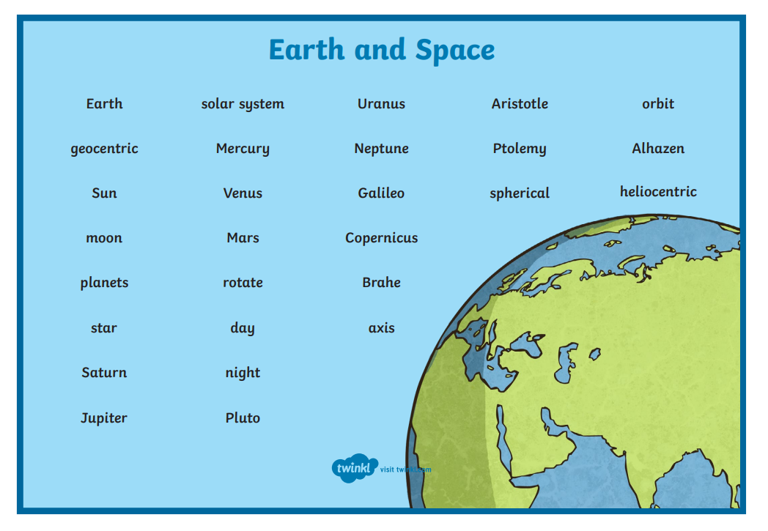
Useful Vocabulary:

Exciting Extras:
- 10th June - Summer Show
- 12th June – Sports Day
- 15th June – Oak Class – 1st Aid (stopping a bleed)
- 19th June – School fete
- 25th June – Culture Day
- 26th & 29th – PD Days
- 1st – 3rd July – Residential trip
- 6th July – Year 5 Bikeability
- 10th July - Reports
- 13th July – End of Year Assembly
- 14th July – Classes move up
- 15th July – Disco!
- 17th July – End of year picnic and break up!
If you have any questions or anything you would like to chat about, please just get in touch .
Kind regards,


Mrs Frost and Mrs Stubbings

