
Oak Class
Autumn 1 – Curriculum Statement
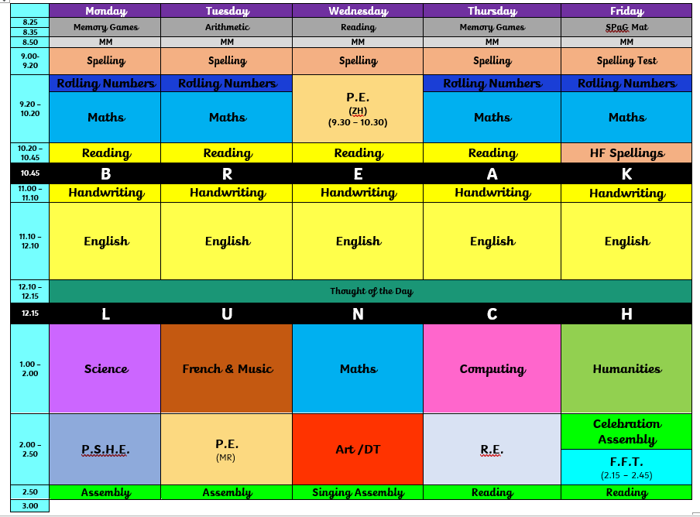
Welcome back to the new school year in Oak Class! I’m sure the amazing new windows will help if the weather stays hot! We have so much planned for this school year, and an exciting Autumn Term coming up…

Science – Electricity! In this unit, the children will learn all about electricity, circuits and symbols. We will be learning all about the correct terminology and symbols required to discuss electricity correctly and to be able to write accurate answers relating to concepts such as ohms, volts and amps.

Humanities – In History, we will cover the origins of the Industrial Revolution in Britain and why it began here, the working lives of adult and child industrial workers, the development of the railways and the changes industrialisation brought to Britain and British society.
Art – In art we will focus on Wildlife and birds – in particular looking at and creating sculpture inspired by the work of Constantin Brancusi and Richard Sweeney.
Music – We will be following the National Music Hub’s unit – Livin’ on a Prayer!
PE will be on Tuesdays and Wednesdays.
The Reading Raffle continues with tickets available every week. If your child forgets to bring their reading record home for you to sign or you have been unable to sign it, please message me via Dojo on a Friday to let me know they have read.
Spellings – Following feedback we will be sending spelling lists home on a weekly basis if you would like to practise them with your children. There is no expectation to return the sheets to school, but a little practise would really help! We are continuing to use Reading Eggs, Writing Legends, Mathletics and TTRS and will be rewarding the effort the children make on these with Dojos!
As always, if you have any questions or anything you would like to chat about, please just get in touch .
Kind regards,

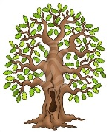
Mrs Frost, Mrs Stubbings, Miss Wallace and Mrs Noble

