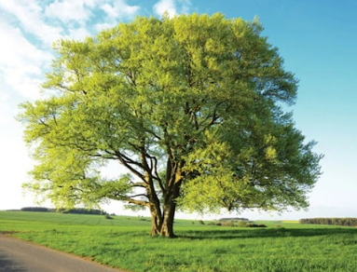

Curriculum Statement

Welcome Back!
We hope you all had a wonderful summer break and are feeling refreshed and ready for an exciting year ahead. We have a busy and engaging term planned, packed with exciting learning opportunities across the curriculum, and we are looking forward to supporting the children as they continue to grow in confidence and independence.

English
This term, we will be using the Grammarsaurus English curriculum to develop the children's writing skills. Through a range of engaging texts and activities, the children will focus on improving their vocabulary, sentence structure, grammar and punctuation, while building their confidence as readers and writers.

Mathematics
In Maths, our focus will be on place value. The children will develop their understanding of numbers, exploring how numbers are represented, compared and ordered. They will use practical resources and problem-solving activities to build confidence and fluency in their mathematical thinking.

Science
In Science, we will be learning about Animals Including Humans. The children will explore the basic needs of animals, including humans, and learn about healthy lifestyles, growth and survival. There will be plenty of opportunities for investigation and discussion throughout the topic.

History
Our History topic this term is The Anglo-Saxons. The children will learn about who the Anglo-Saxons were, why they came to Britain, and how they lived. They will explore Anglo-Saxon settlements, beliefs, and the impact this period had on Britain's history.

Art
In Art, we will be studying European Art. The children will explore the work of a range of European artists and experiment with different artistic styles, techniques and media to create their own pieces inspired by their learning.

Computing
In Computing, the children will be learning about Sequencing Sounds. They will develop their understanding of instructions and algorithms by creating and organising sequences of sounds, helping them build the foundations of coding and computational thinking.

PE
Children will be doing PE with Mrs Reidi on Tuesdays and Thursdays. They will be doing Team Building and Cross Country.

Reading
Reading remains at the heart of our curriculum. Just a few minutes of reading at home each day makes a huge difference to children's confidence and progress. Please continue to hear your child read at least five times a week and sign their reading record.
Reading Raffle: Each Friday, we count how many times your child has read at home. They receive the same number of raffle tickets, and one lucky winner receives a small prize.

Working Together
Thank you for your continued support. We are excited for the year ahead and look forward to working in partnership with you to ensure your child has a happy, successful and memorable year.
Homework
Following feedback, we will be sending spellings home weekly for children to complete. There is no expectation to return these but will help your child prepare for the next week’s spellings.
We will continue to use Reading Eggs, Writing, Legends, TTRS and Mathletics and will be rewarding the effort the children make on these with Dojos.

Here is our timetable for the Summer Term.
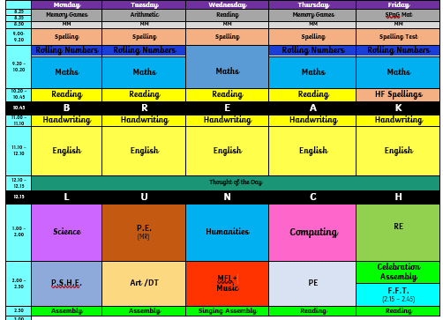
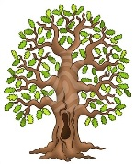
We’re really looking forward to another fantastic term in Beech Class. Kind regards, Team Beech – Mrs Sismey, Miss Walters and Mr Scott.

