Dear Parents/Carers,
We hope you’ve had a wonderful summer break! I’m very much looking forward to teaching your children this year. This half term promises to be an exciting time for us all as we begin getting to know one another and settling into school life—with plenty of fun along the way! Below, you’ll find an overview of what we’ll be learning this term. If you have any questions, please do not hesitate to come and speak to us—we’re always happy to help. You can also visit our class page on the school website for more updates and information.
Mrs. Barrow and the Acorn Team
Maths
We will begin our maths learning, looking at and learning to match, sort and compare objects.
We will also begin to recognise and count in numbers 1, 2 and 3.
We will finish this term learning about size, capacity and exploring different patterns.
Vocabulary:
Sort, share, match, compare, look, one, two, three, count, recognise, measure, pattern.

Personal, Social and Emotional Development

We will be learning to:
- Be kind to each other
- Taking turns and playing nicely together.
- Sharing.
- Consider the feelings of others.
We will also introduce circle time where we learn sit nicely and listen to others.
Vocabulary:
Kind, help, share, happy, sad, taking turns.

Phonics
We will begin our phonics learning during week 2 of this term. We will be learning to recognise phonemes and begin to form letters. The phonemes we have learned each week will be sent home on a Friday via Dojo.

Acorn Class
Curriculum Statement
Autumn 1
Marvellous Me!
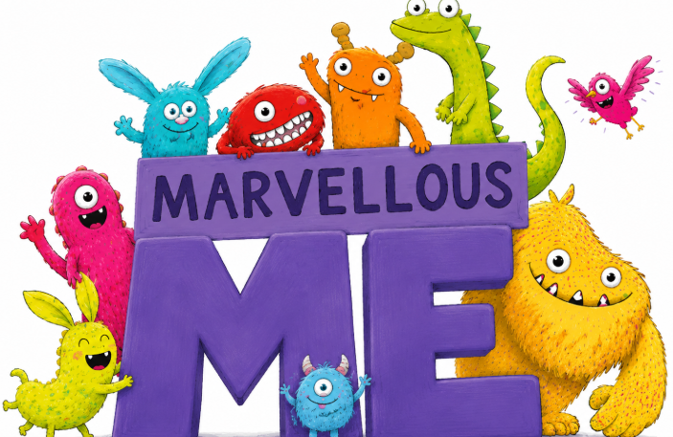
Our nursery children will be learning through the same exciting themes and topics, with activities carefully adapted to match their stage of develop and support their next steps in learning.

Communication and Language
To further our communication and language we will;
- Engage in story time.
- Re-tell the story Elmer.
- Encourage listening carefully to each other.

Literacy
We will be reading the story Elmer.
Learning to re-tell the story verbally and with actions.
We will use what we know about the story to create a class story map.

Expressive Art and Design

We will be exploring different outdoor materials to create a person, discussing the different body parts as we go.

We will also be drawing a self portrait and adding these to our class display!

Vocabulary:
Model, make, materials, drawing, build,

Understanding of the World.
We will be learning all about our bodies, talking about its different parts and what our senses are.
We will learn about where we live and discuss our families.
We will also learn about the people who help us, and who has helped others in the past.
Vocabulary:
Mum, Dad, sister, brother, grandparents, Florence Nightingale, nurse, firefighters, Doctors, paramedic, police, head, neck, arms, legs knee, feet, hands, face, eyes, ears, nose, mouth, senses.

Physical Development
To develop our physical development, we will be taking part in activities such as; funky fingers, dough disco, pencil control activities and learning to use scissors.
PE will be taught on Friday afternoon by Mrs Hovell.
Please make sure children come to school in their PE kit with long hair tied back and earrings removed.

We have also incorporated all areas of learning into the Continuous Provision within Acorn Class.
Exciting Extras
A visit from a nurse!
Stay and Play: ‘You, Me, Us!’ An exciting afternoon of activities for you and your children to enjoy in our classroom. This will be on Wednesday 7th October at 1:30pm.

